



Appendix 1

A card game
"Images and data protection"
(MATERIALS FOR TRAINERS & EDUCATORS)

The card game consists of:

18 stories
12 perpetrator roles
learn
12 victim roles
&
3 judge roles
have
fun

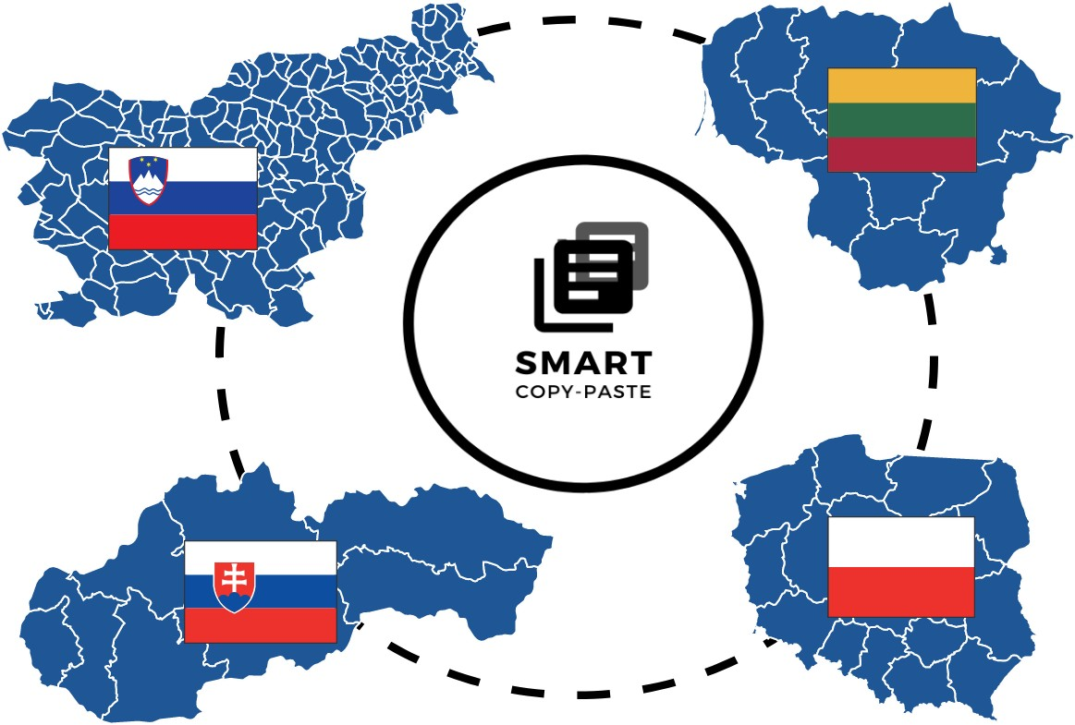




Roles
for 12 participants

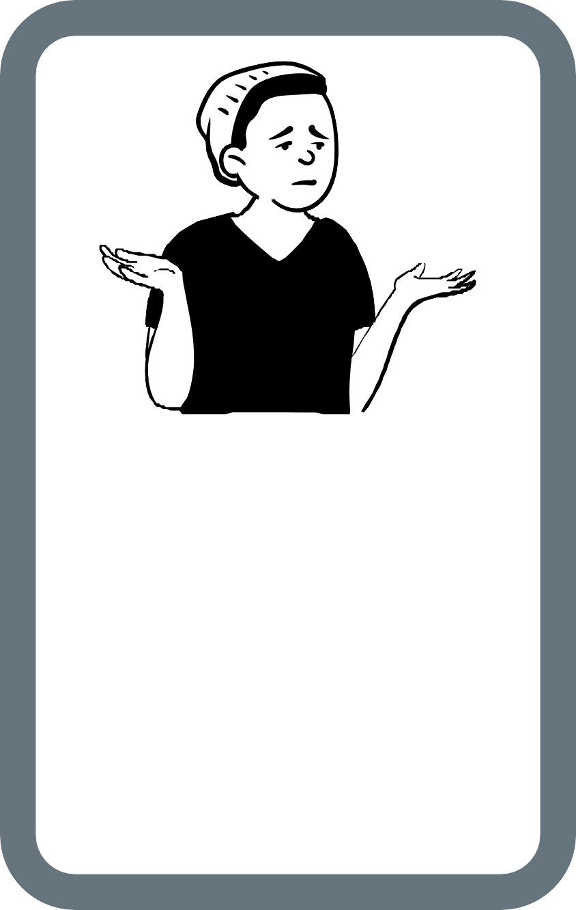
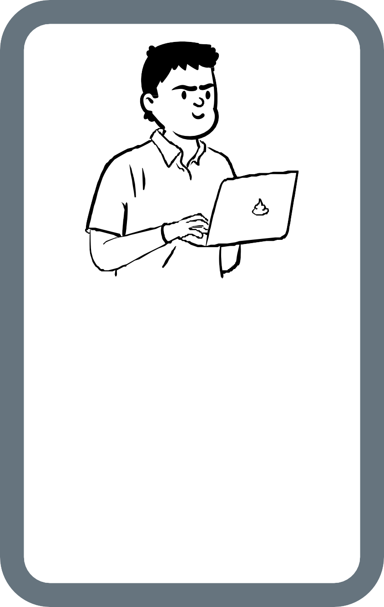
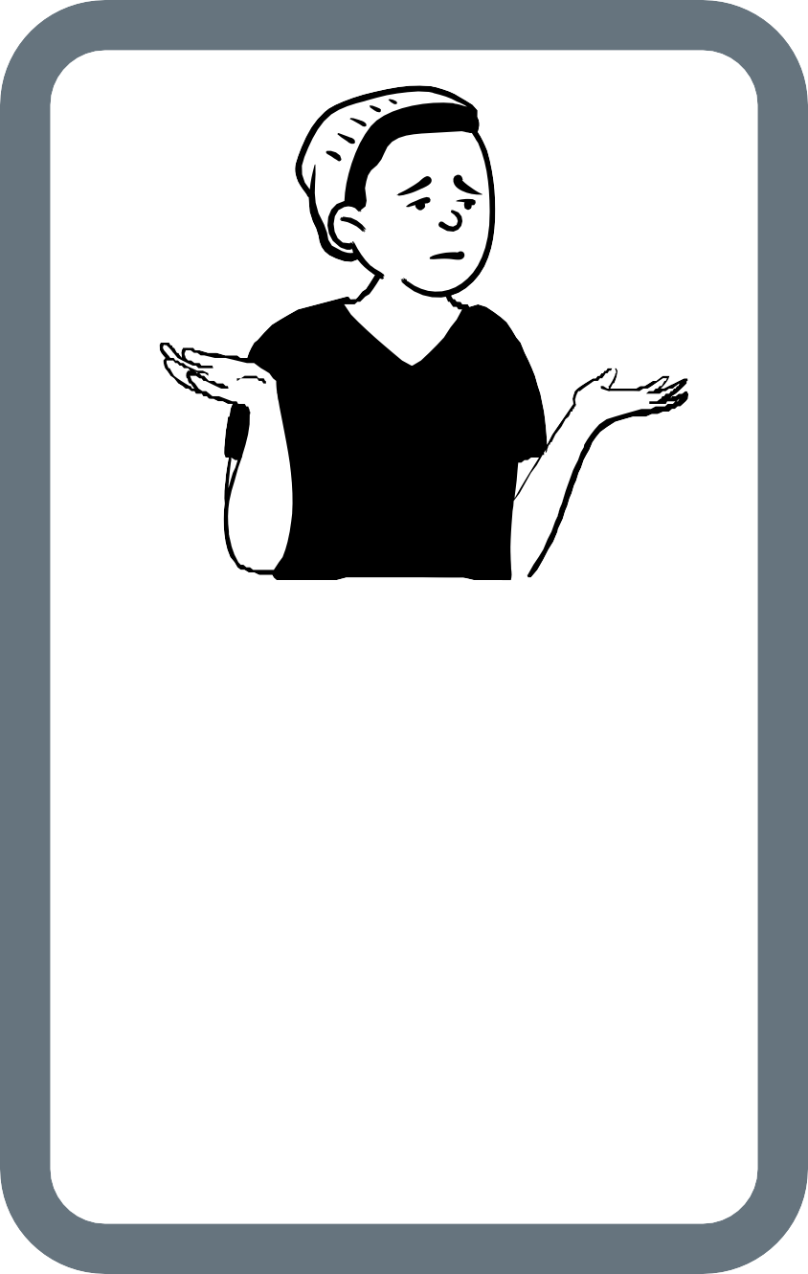

VICTIM
WHO IS THE VICTIM?
WHAT CONSEQUENCES FOR THIS PERSON(S)
ARISE FROM THIS SITUATION?

PERPETRATOR
WHAT WAS HIS/HER MOTIVATION TO DO THAT?

VICTIM
WHO IS THE VICTIM?
WHAT CONSEQUENCES FOR THIS PERSON(S)
ARISE FROM THIS SITUATION?

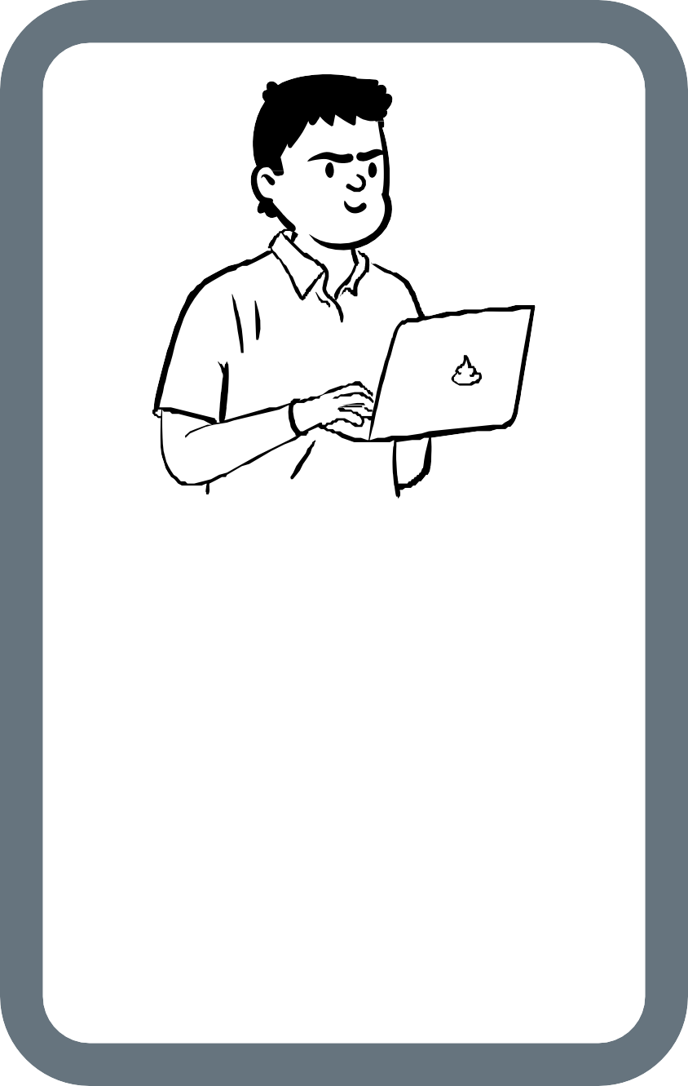
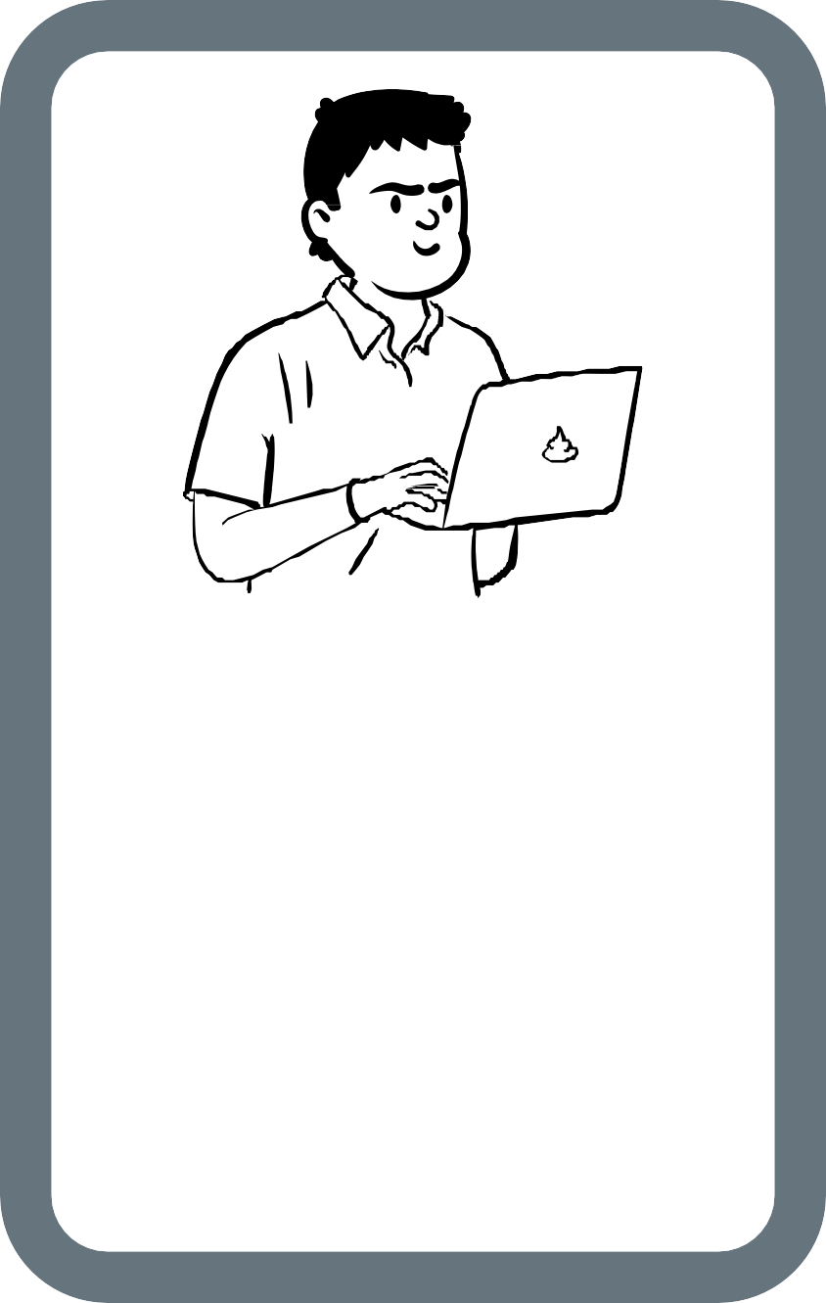
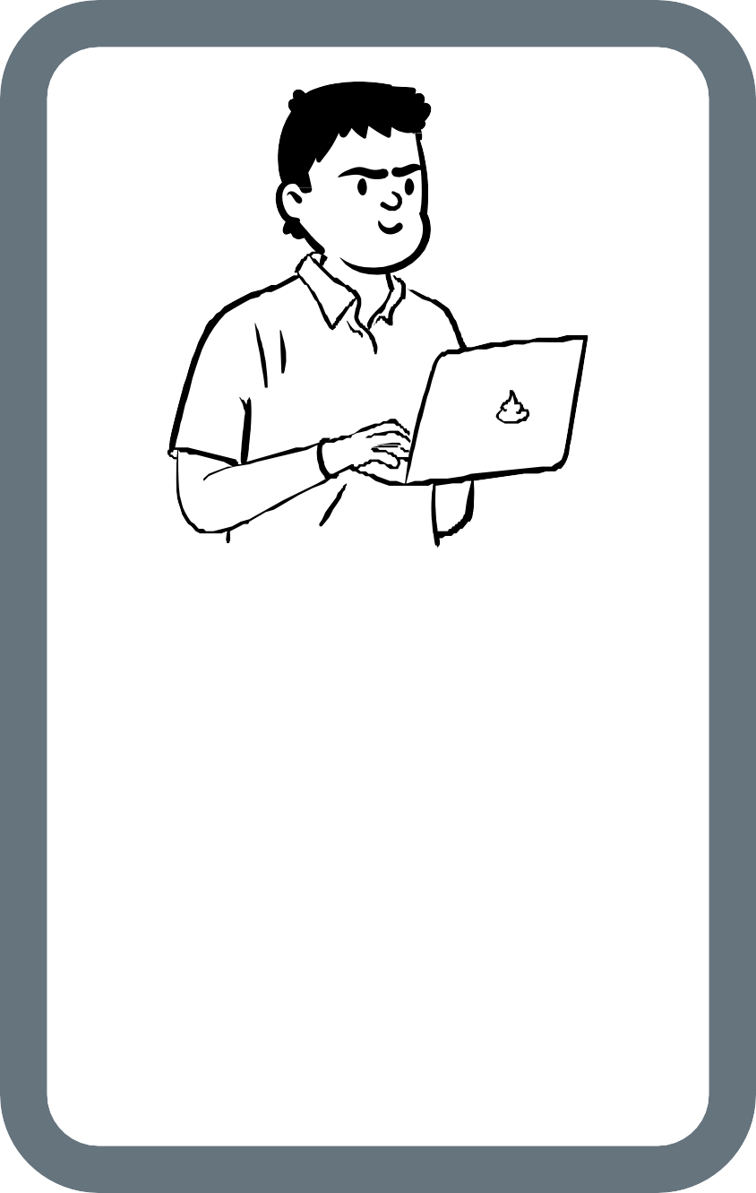

PERPETRATOR
WHAT WAS HIS/HER MOTIVATION TO DO THAT?

PERPETRATOR
WHAT WAS HIS/HER MOTIVATION TO DO THAT?

PERPETRATOR
WHAT WAS HIS/HER MOTIVATION TO DO THAT?

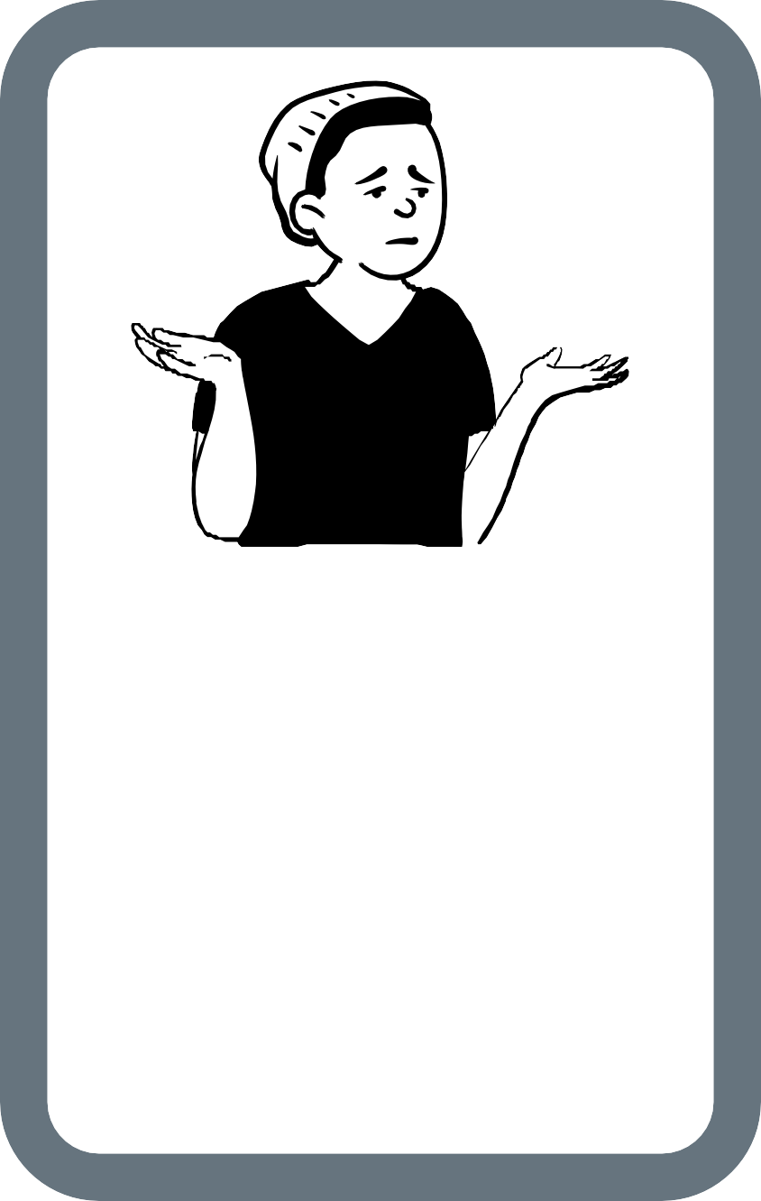
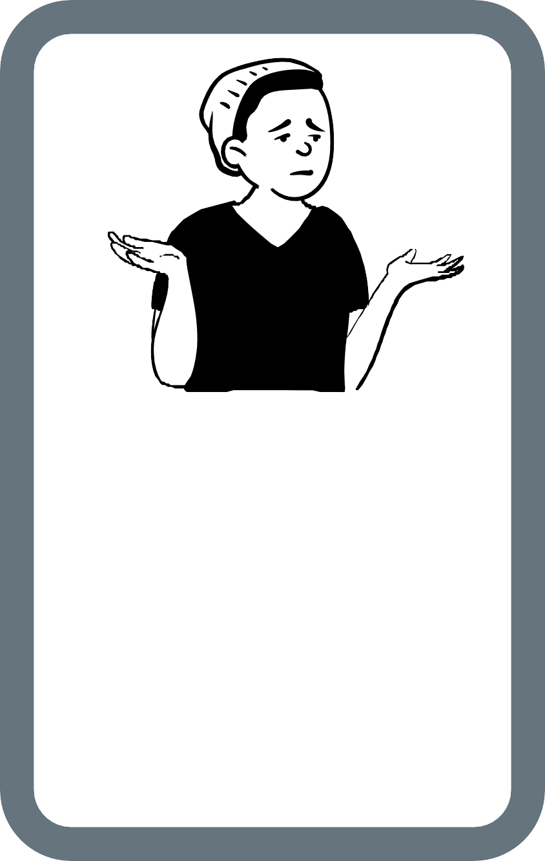
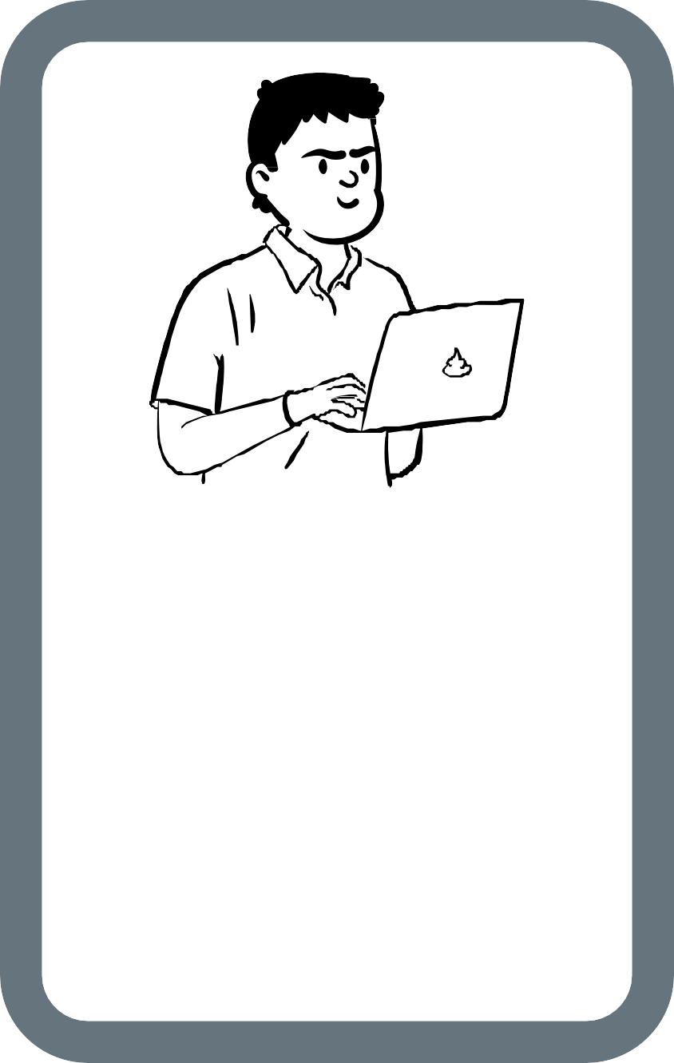
VICTIM

VICTIM
WHO IS THE VICTIM?
WHAT CONSEQUENCES FOR THIS PERSON(S)
ARISE FROM THIS SITUATION?

PERPETRATOR
WHAT WAS HIS/HER MOTIVATION TO DO THAT?

WHO IS THE VICTIM?
WHAT CONSEQUENCES FOR THIS PERSON(S)
ARISE FROM THIS SITUATION?

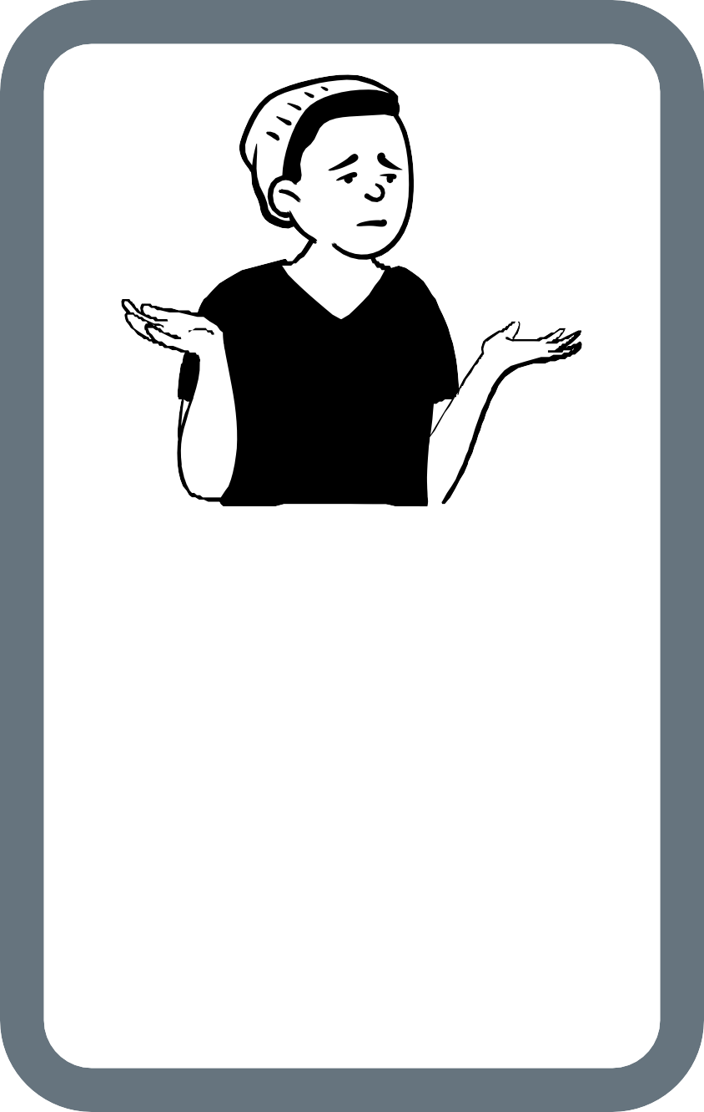
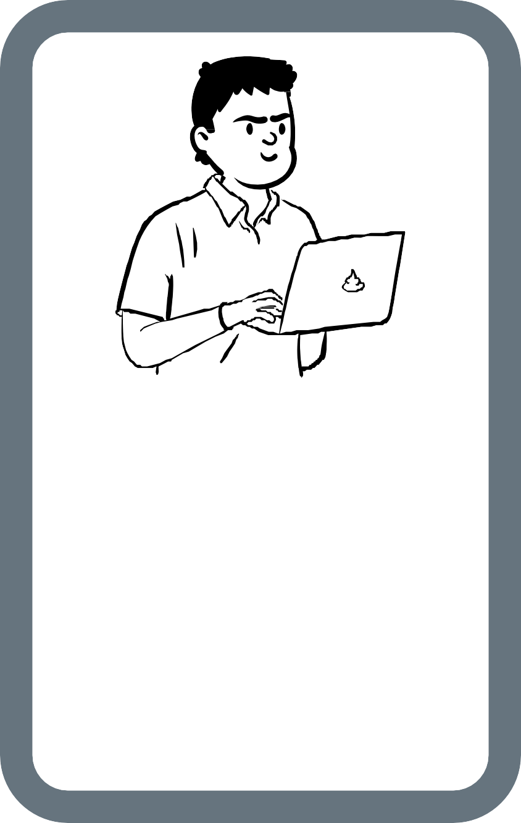
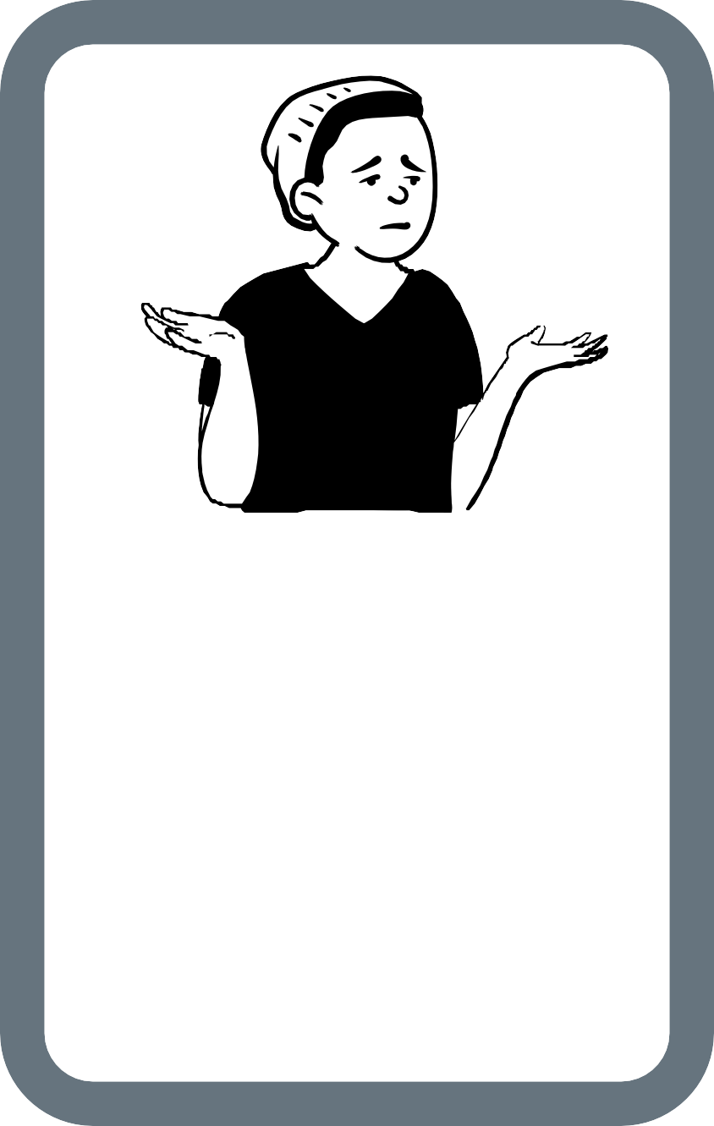

VICTIM
WHO IS THE VICTIM?
WHAT CONSEQUENCES FOR THIS PERSON(S)
ARISE FROM THIS SITUATION?

PERPETRATOR
WHAT WAS HIS/HER MOTIVATION TO DO THAT?

VICTIM
WHO IS THE VICTIM?
WHAT CONSEQUENCES FOR THIS PERSON(S)
ARISE FROM THIS SITUATION?

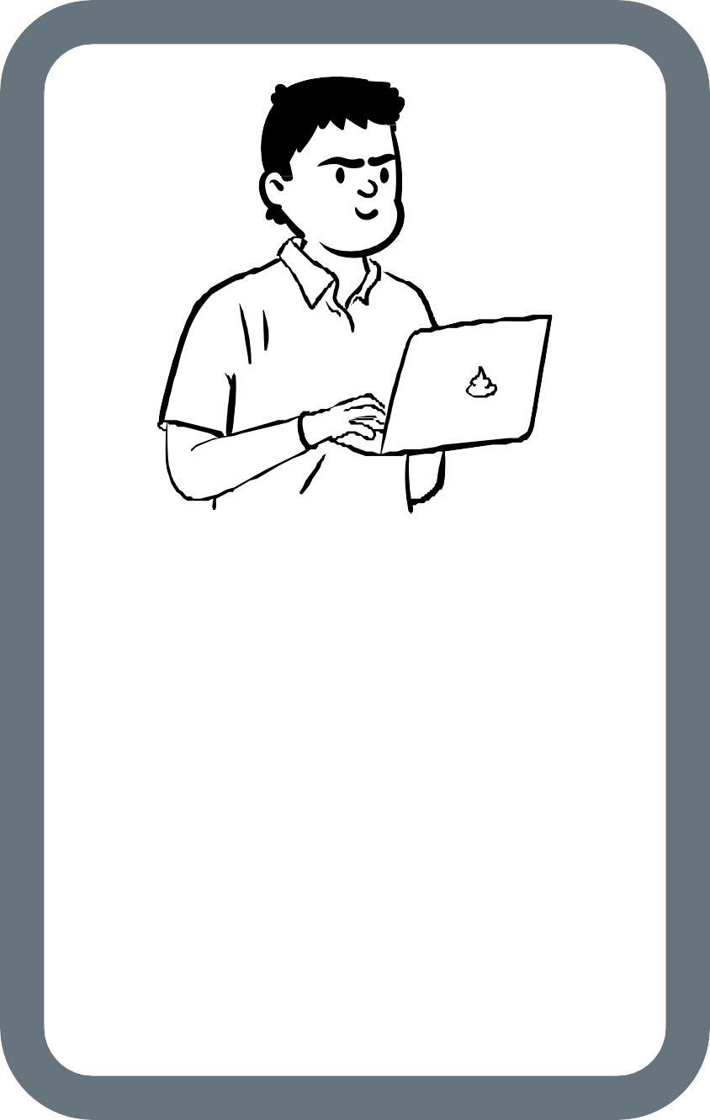
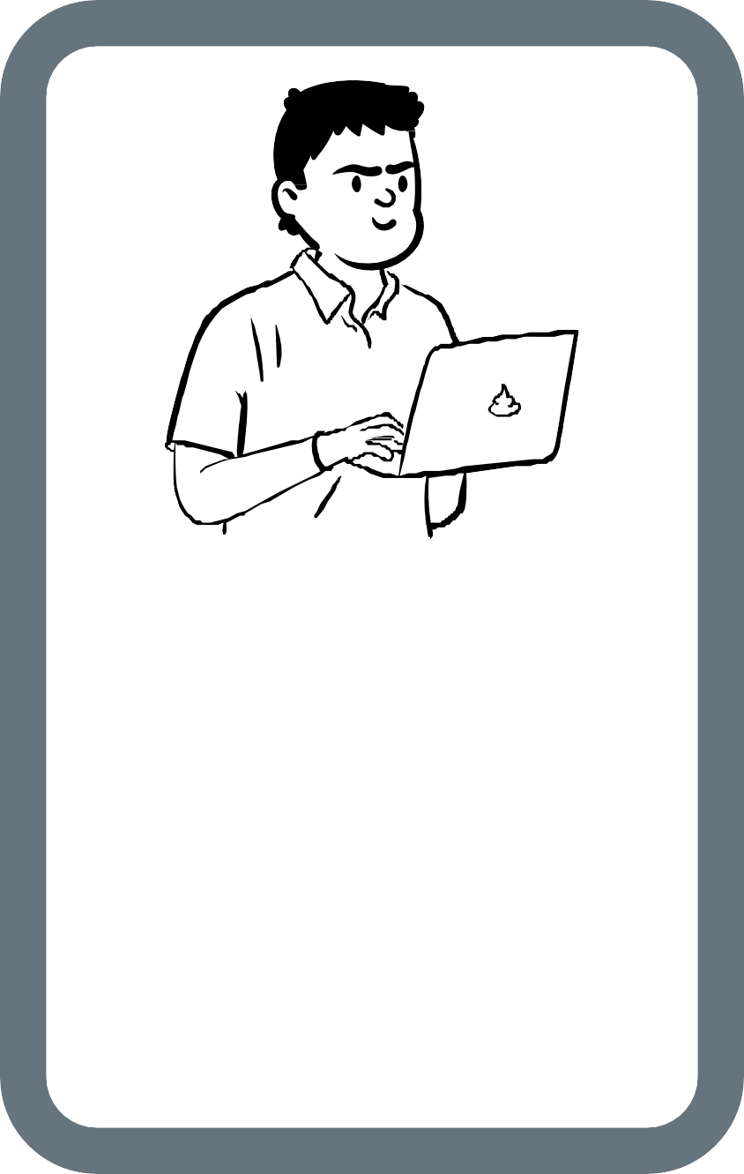
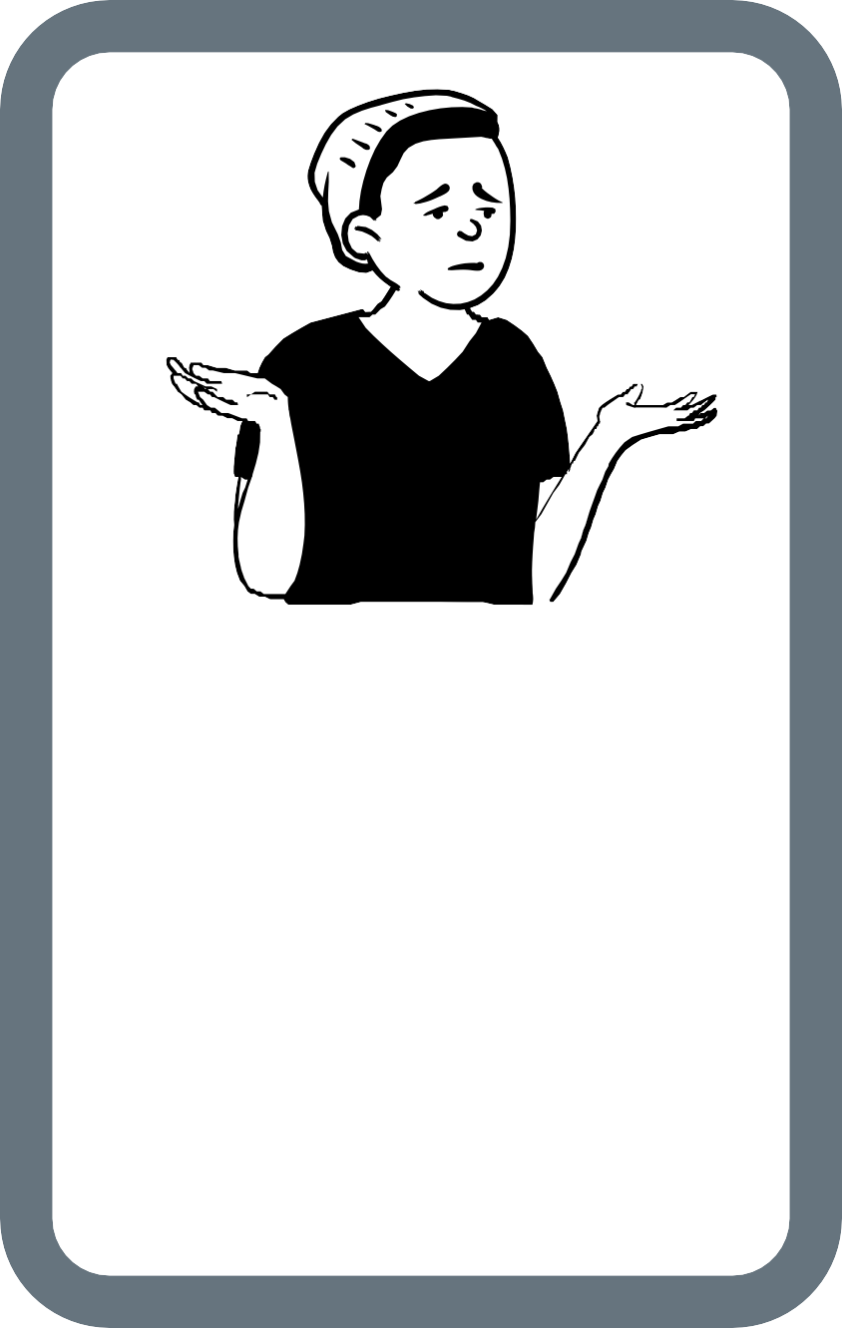

PERPETRATOR
WHAT WAS HIS/HER MOTIVATION TO DO THAT?

PERPETRATOR
WHAT WAS HIS/HER MOTIVATION TO DO THAT?

VICTIM
WHO IS THE VICTIM?
WHAT CONSEQUENCES FOR THIS PERSON(S)
ARISE FROM THIS SITUATION?
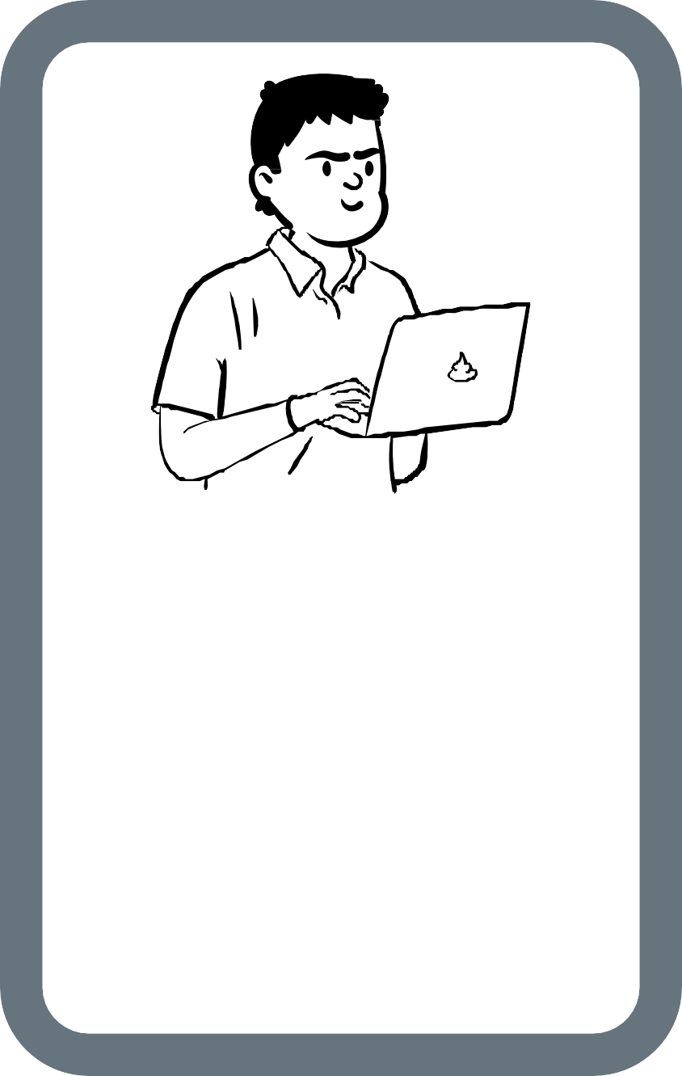

VICTIM
WHO IS THE VICTIM?
WHAT CONSEQUENCES FOR THIS PERSON(S)
ARISE FROM THIS SITUATION?

PERPETRATOR
WHAT WAS HIS/HER MOTIVATION TO DO THAT?

VICTIM
WHO IS THE VICTIM?
WHAT CONSEQUENCES FOR THIS PERSON(S)
ARISE FROM THIS SITUATION?

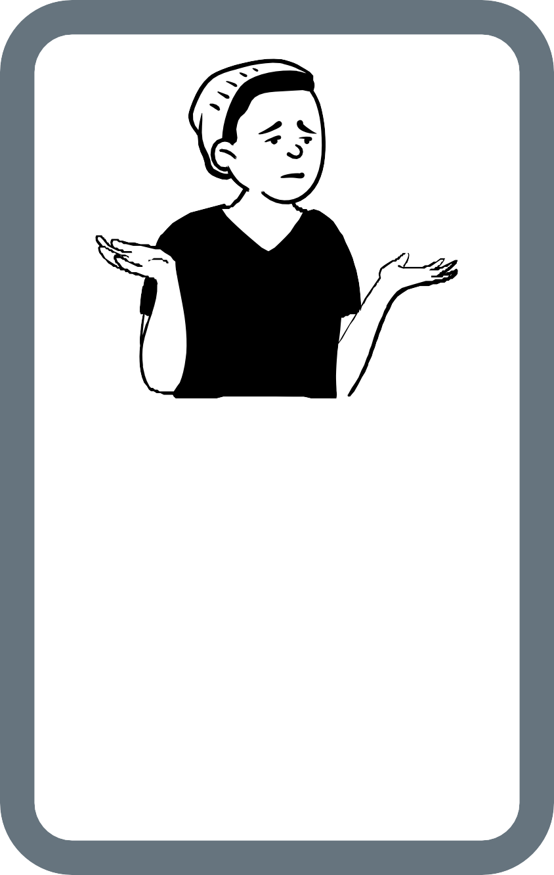
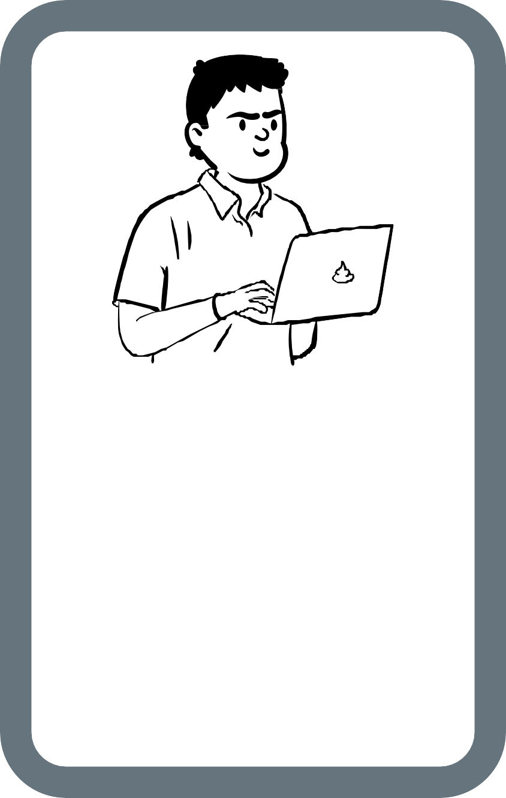
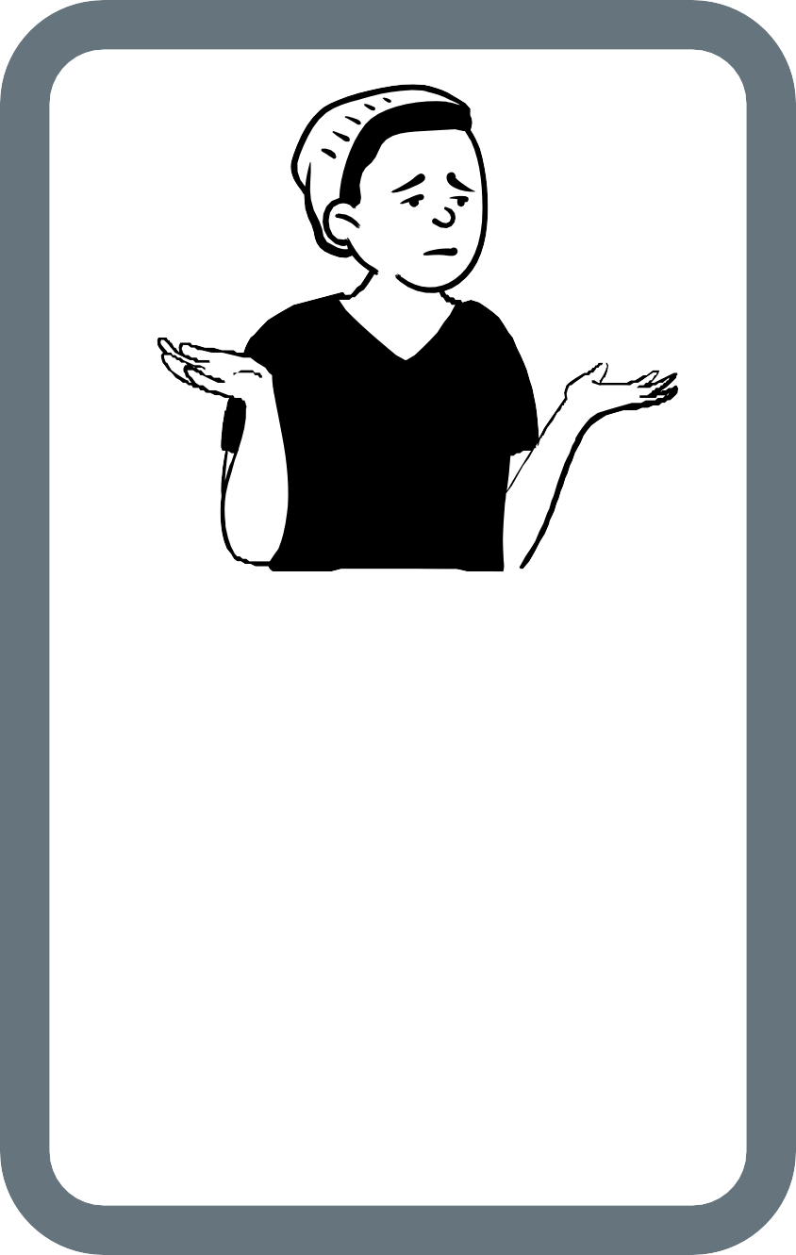

VICTIM
WHO IS THE VICTIM?
WHAT CONSEQUENCES FOR THIS PERSON(S)
ARISE FROM THIS SITUATION?

PERPETRATOR
WHAT WAS HIS/HER MOTIVATION TO DO THAT?

VICTIM
WHO IS THE VICTIM?
WHAT CONSEQUENCES FOR THIS PERSON(S)
ARISE FROM THIS SITUATION?

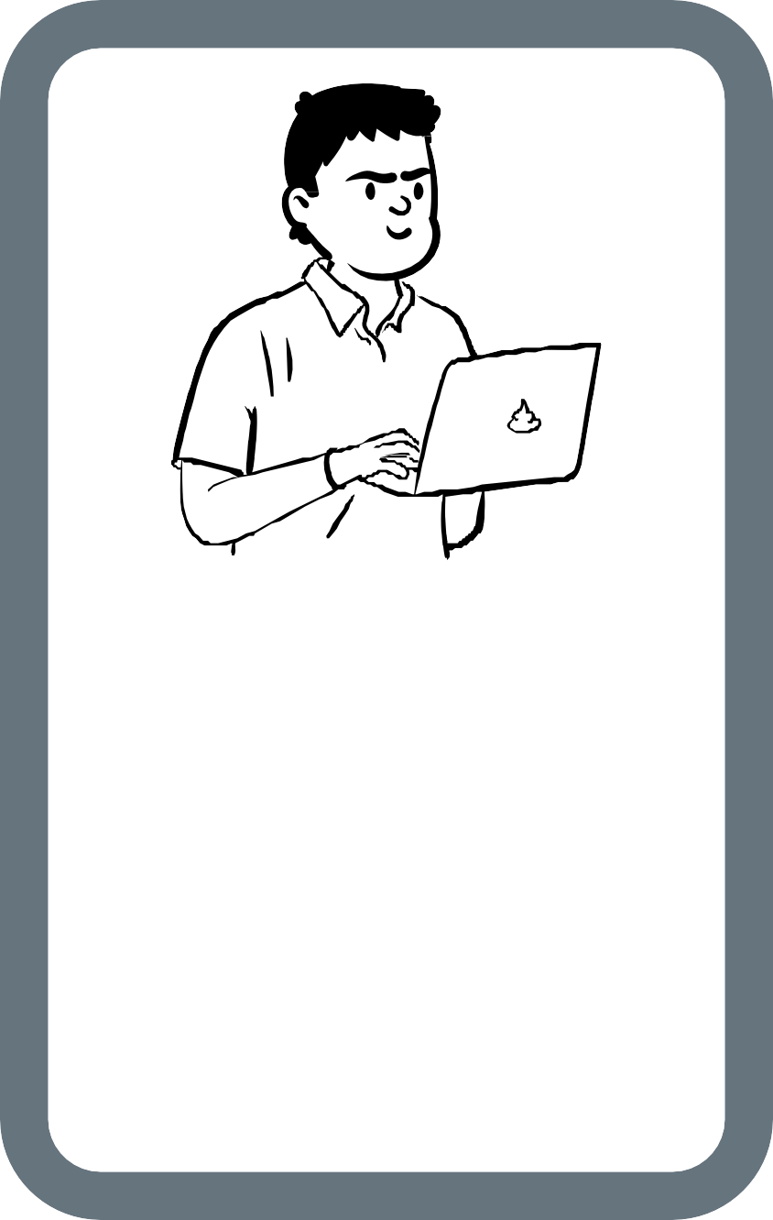
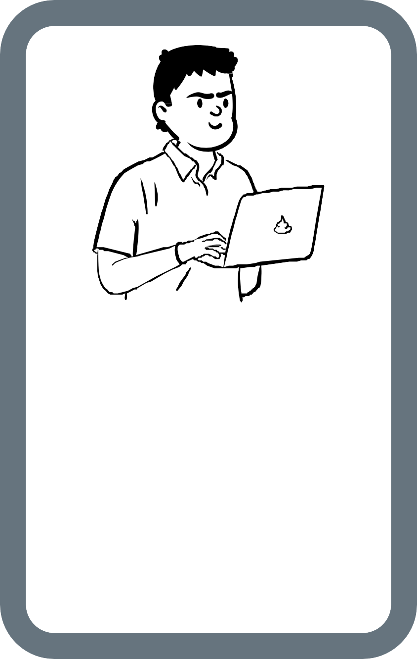
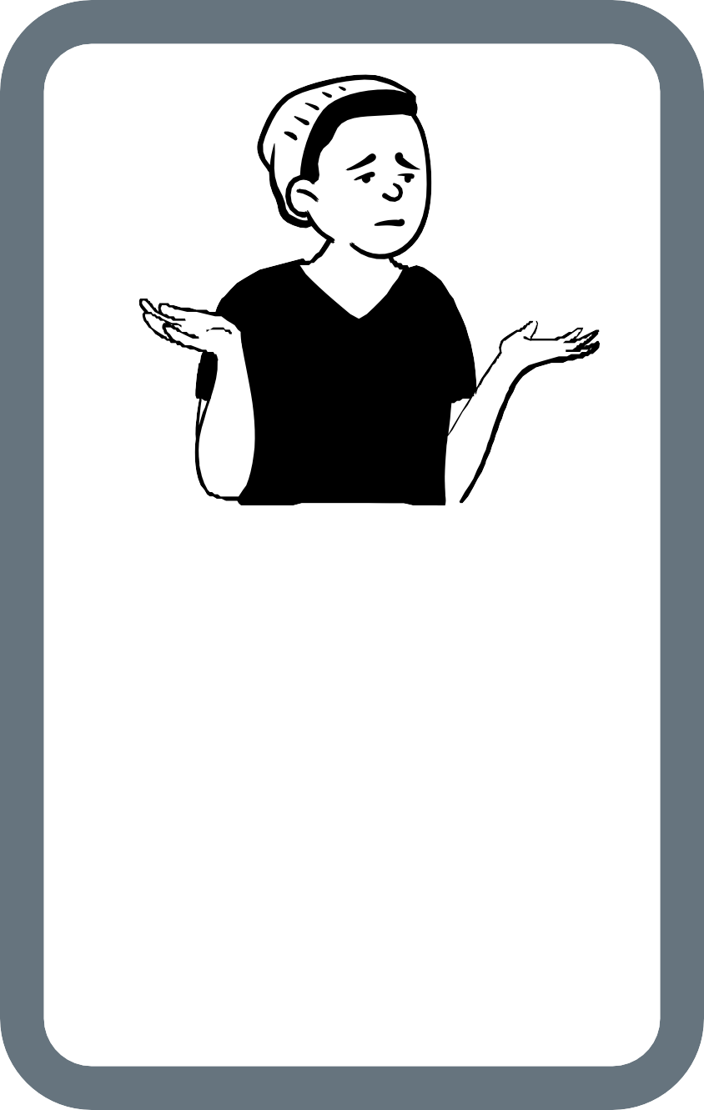

PERPETRATOR
WHAT WAS HIS/HER MOTIVATION TO DO THAT?

PERPETRATOR
WHAT WAS HIS/HER MOTIVATION TO DO THAT?

VICTIM
WHO IS THE VICTIM?
WHAT CONSEQUENCES FOR THIS PERSON(S)
ARISE FROM THIS SITUATION?


JUDGE

JUDGE

Cards for judges

JUDGE

GUILTY

GUILTY

GUILTY

INNOCENT

INNOCENT

INNOCENT

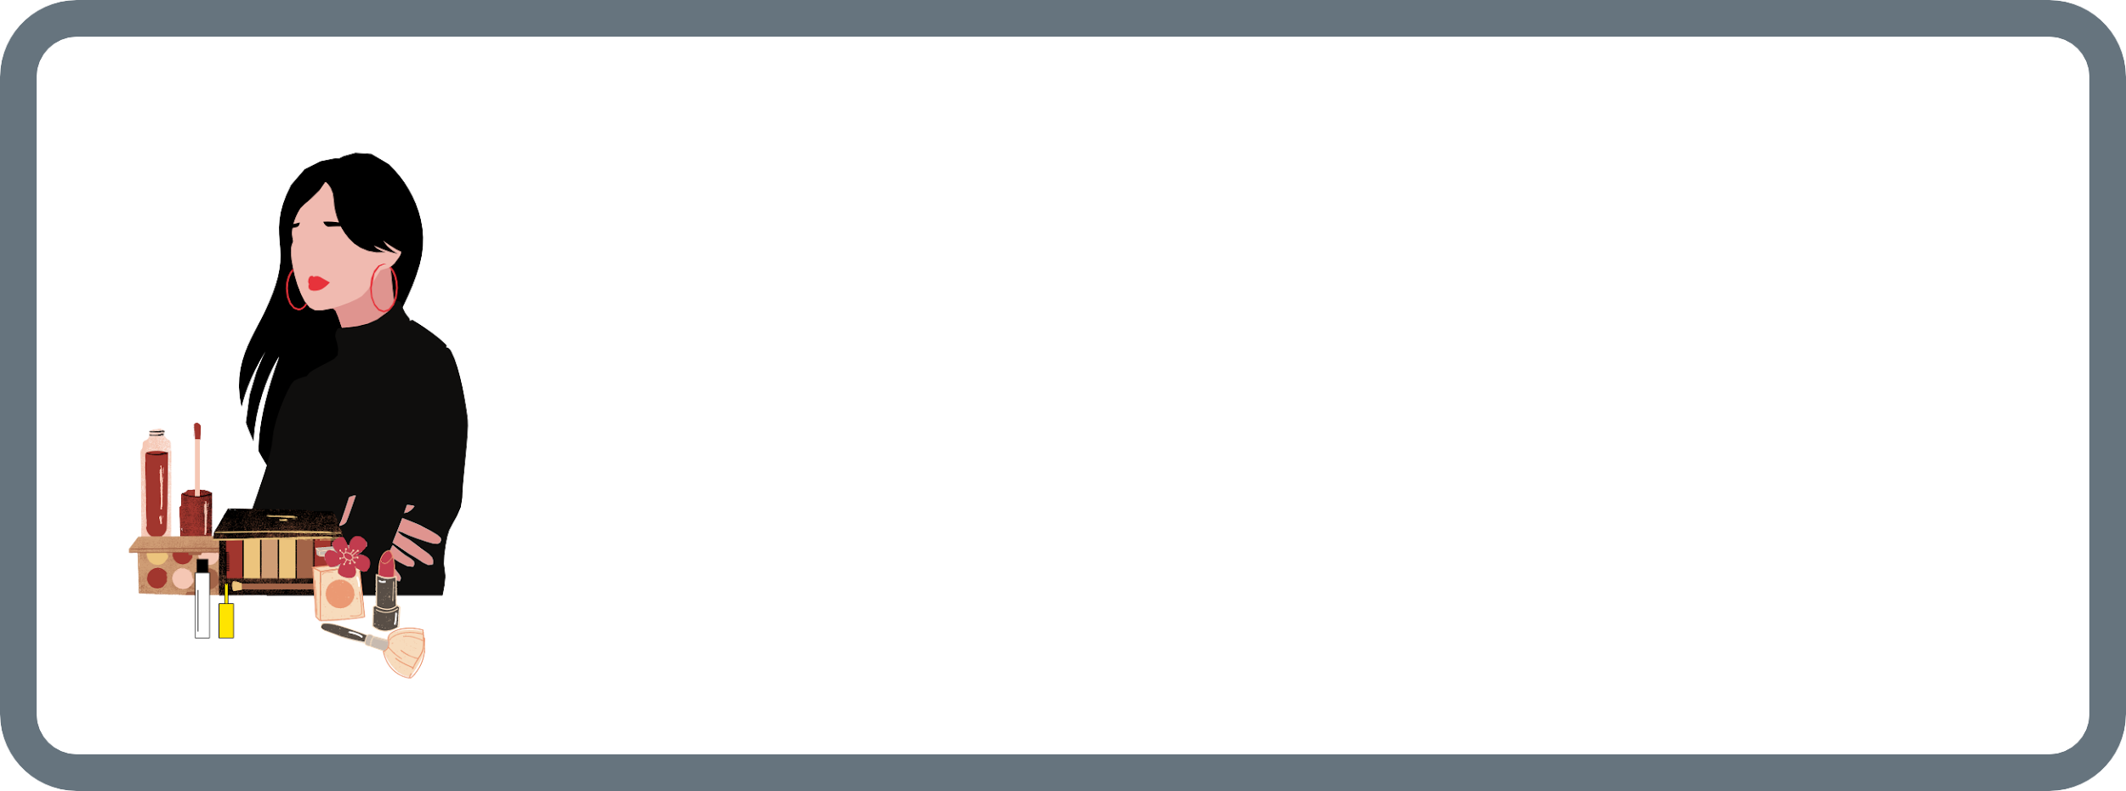

IMAGE THEFT
You are a famous traveler, and you usually post a lot of photos on various social networks and have your own program on TV. You recently noticed that your private photos have been used for a cosmetics promotion campaign. Visualizations of cosmetics are combined with your photos, and the content of the post contains quotes of your statements that you have never said. Additionally, you have never heard of such cosmetic products.

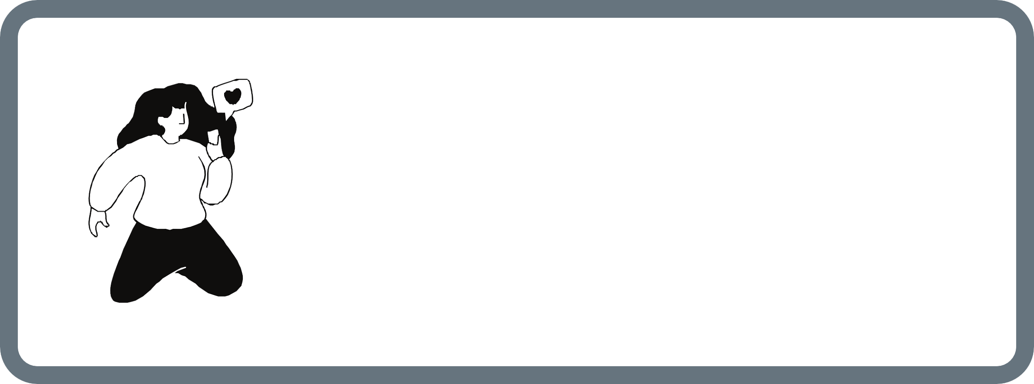

ONLINE DATING SERVICE
You have been registered on a dating site for 4 months because you finally want to find the love of your life. However, no one writes to you or responds to your dating invitations. You know that your body is not perfect, and you cannot afford professional photo sessions (as other people do). You search the Internet and find an unfamous photo model and copy her photos to your dating profile. Immediately after that you notice 17 interesting people who liked your profile at once. A few days later, you receive an email from that unfamous photo model.

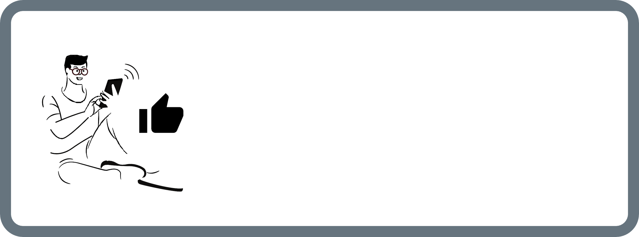

A CONTEST WITH PROBLEMS
There is a contest for an iPhone 10 announced on Facebook. In the content of the post you find a rule that the first 300 people win. To receive the prize, you have to send your home address, name and surname in a private message. You can see that the post has a lot of "likes" and positive comments. You really want to win. What is more, you can see that the post was published 5 minutes ago - so you have a great chance to win. After a few days, you receive several parcels on your address, and the courier expects you to pay 553 euros for them.
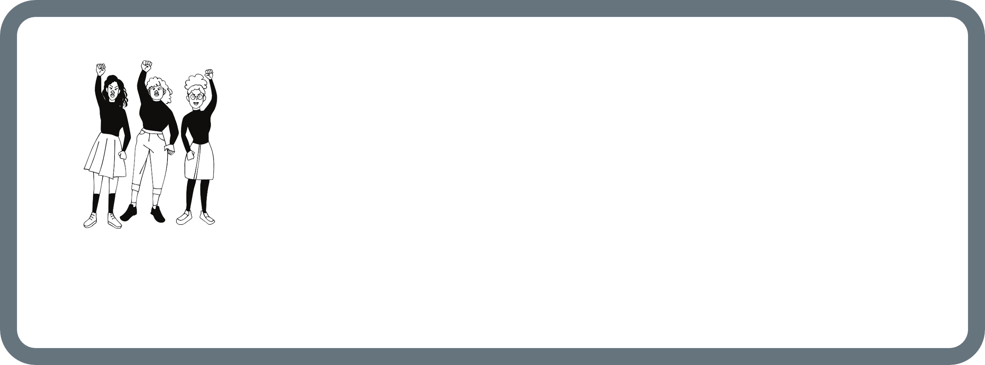
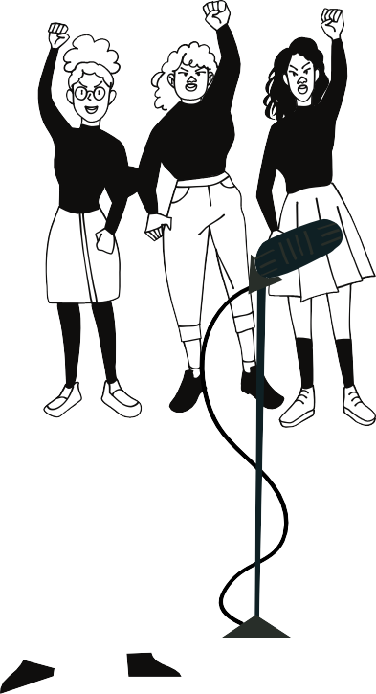
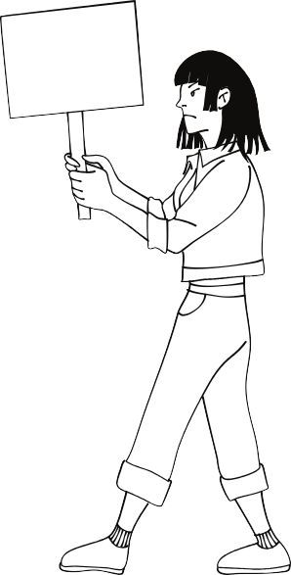

DDID I SAY THAT?
You are participating in the march against violence against women. You are stopped by an insistent TV journalist. Television is known for its controversial programmes and statements of their guests. You give an interview highlighting your protective pro-female position. A few hours after the march, you watch the news and realize that your speech has been falsified and some parts of the conversation have been cut out. They changed the meaning of your speech and put your surname on the TV line.
STOP
being
victim

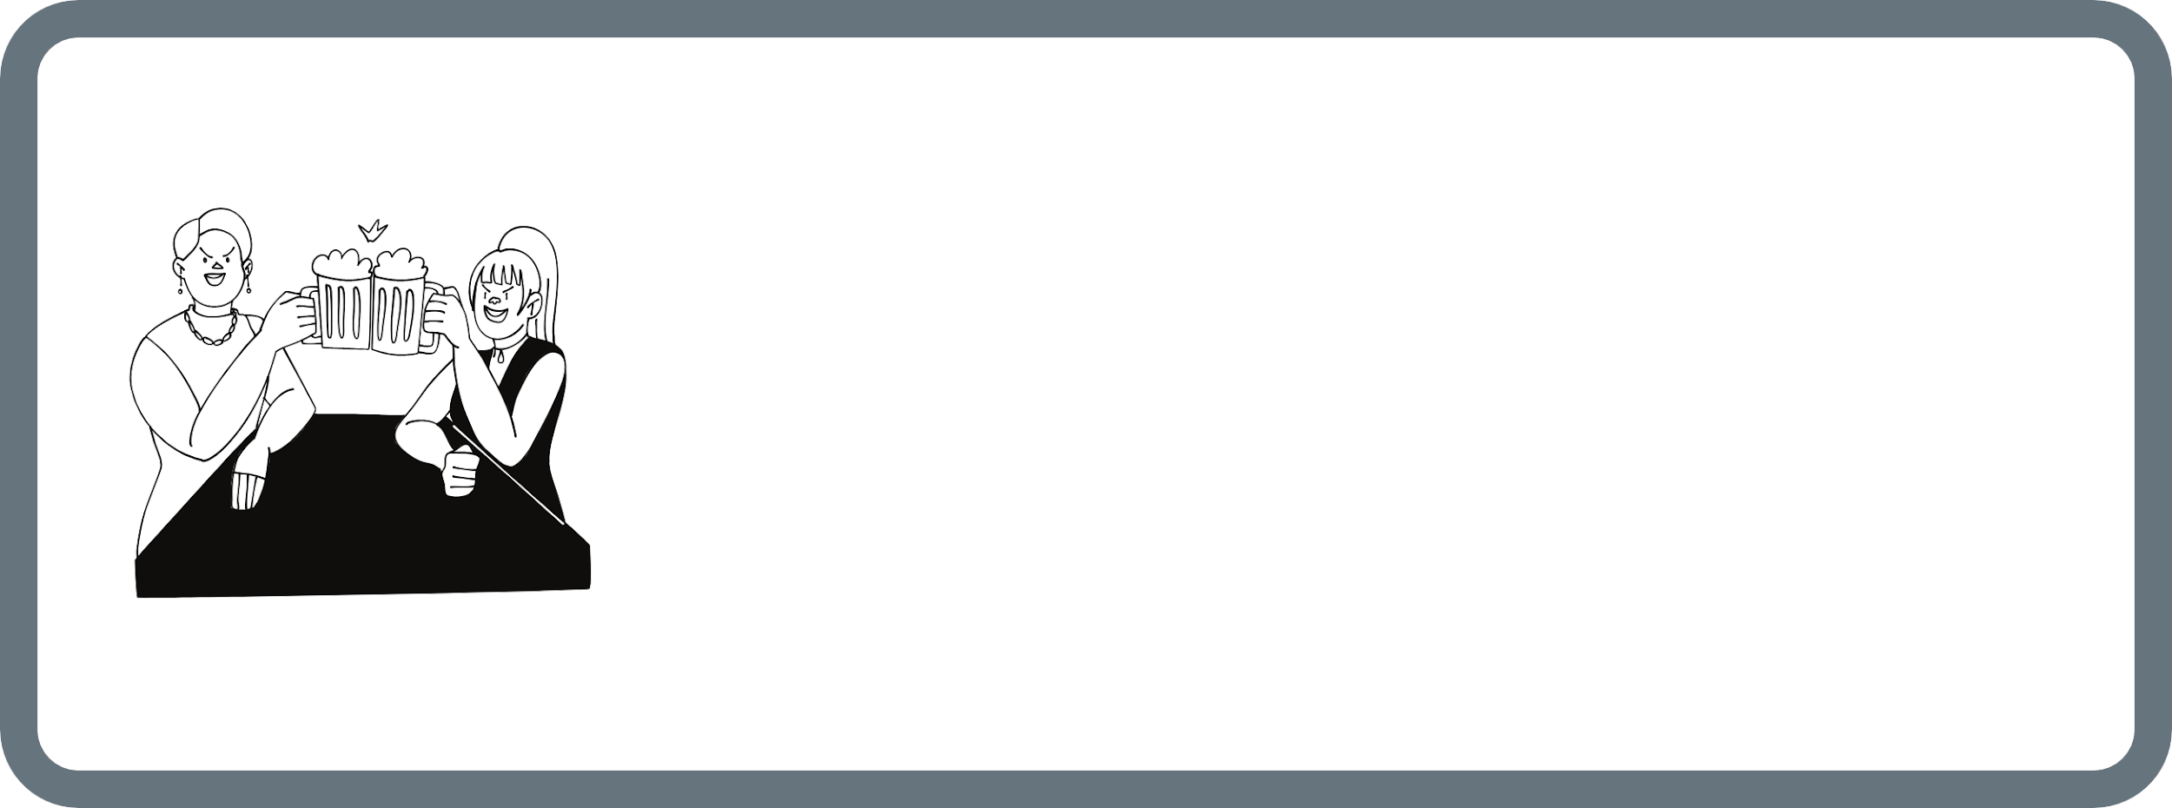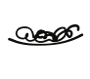

LOOKING FOR A NEW JOB
You are friends with Anna who is a party animal. She often publishes photos from her everyday events on social media. Anna works as a bartender, so public photos with alcohol are not a problem for her. On the other hand, you are interested in working for an international corporation in the nearest future. You used to agree to take photos together at parties in the past, but now you are applying for a job. Your future boss can see it. You are hopelessly asking your friend to delete your photos and name tags on them, since in your past you had no problem with it, but now the situation is different.

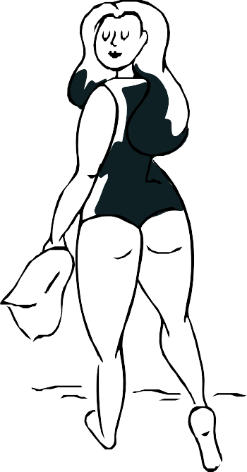

IINSTASTORY
You love posting intimate photos on Instagram. You often received a lot of positive comments that your body looks perfect. However, now more and more followers write offensive comments and believe that such photos cannot be published on social media. Some of your photos have already been blocked due to the level of nudity. You feel that you are a victim of online harassment and you know that reporting people's comments has no effect. The amount of hatred is increasing ....

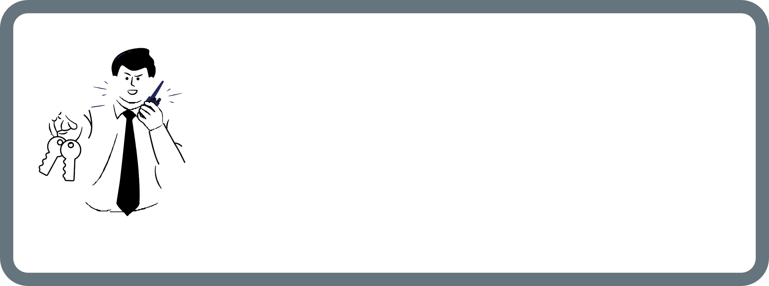

ACCESS TO YOUR DATA
You take part in a community project lasting for 3 years. At each workshop and training, you receive an attendance list to be signed. There is information on which institution is the administrator of your personal data and how to e-mail them. One year after the project was started, you changed your place of residence. You are asking the project coordinator to update your personal data, but he refuses, claiming that he has no access to the data and cannot update it.

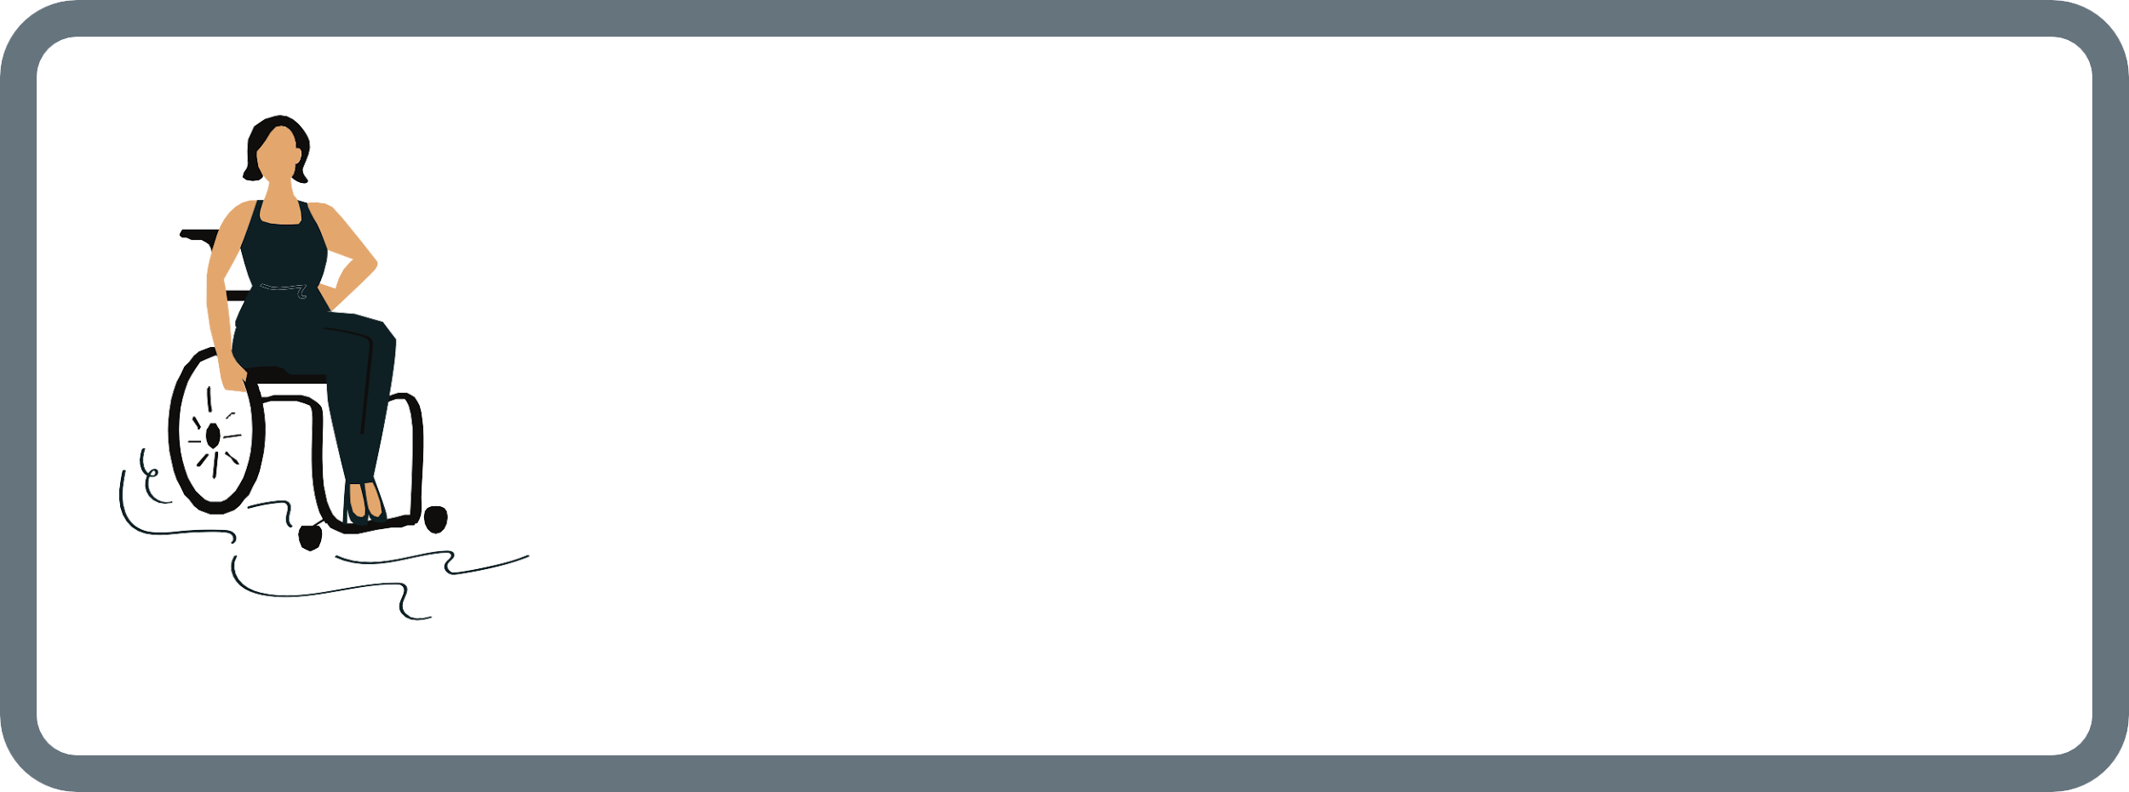

SENSITIVE DATA
You are going on an international exchange with the Erasmus+ program. You are a disabled person, so you need the support of the sending and receiving organization.
The project coordinator from the host organization asks you a lot of direct questions about your health, previous illnesses, medications you take, and your movement abilities. The coordinator asks many personal questions. You feel uncomfortable because he is treating you overzealously, constantly emphasizing your barriers.

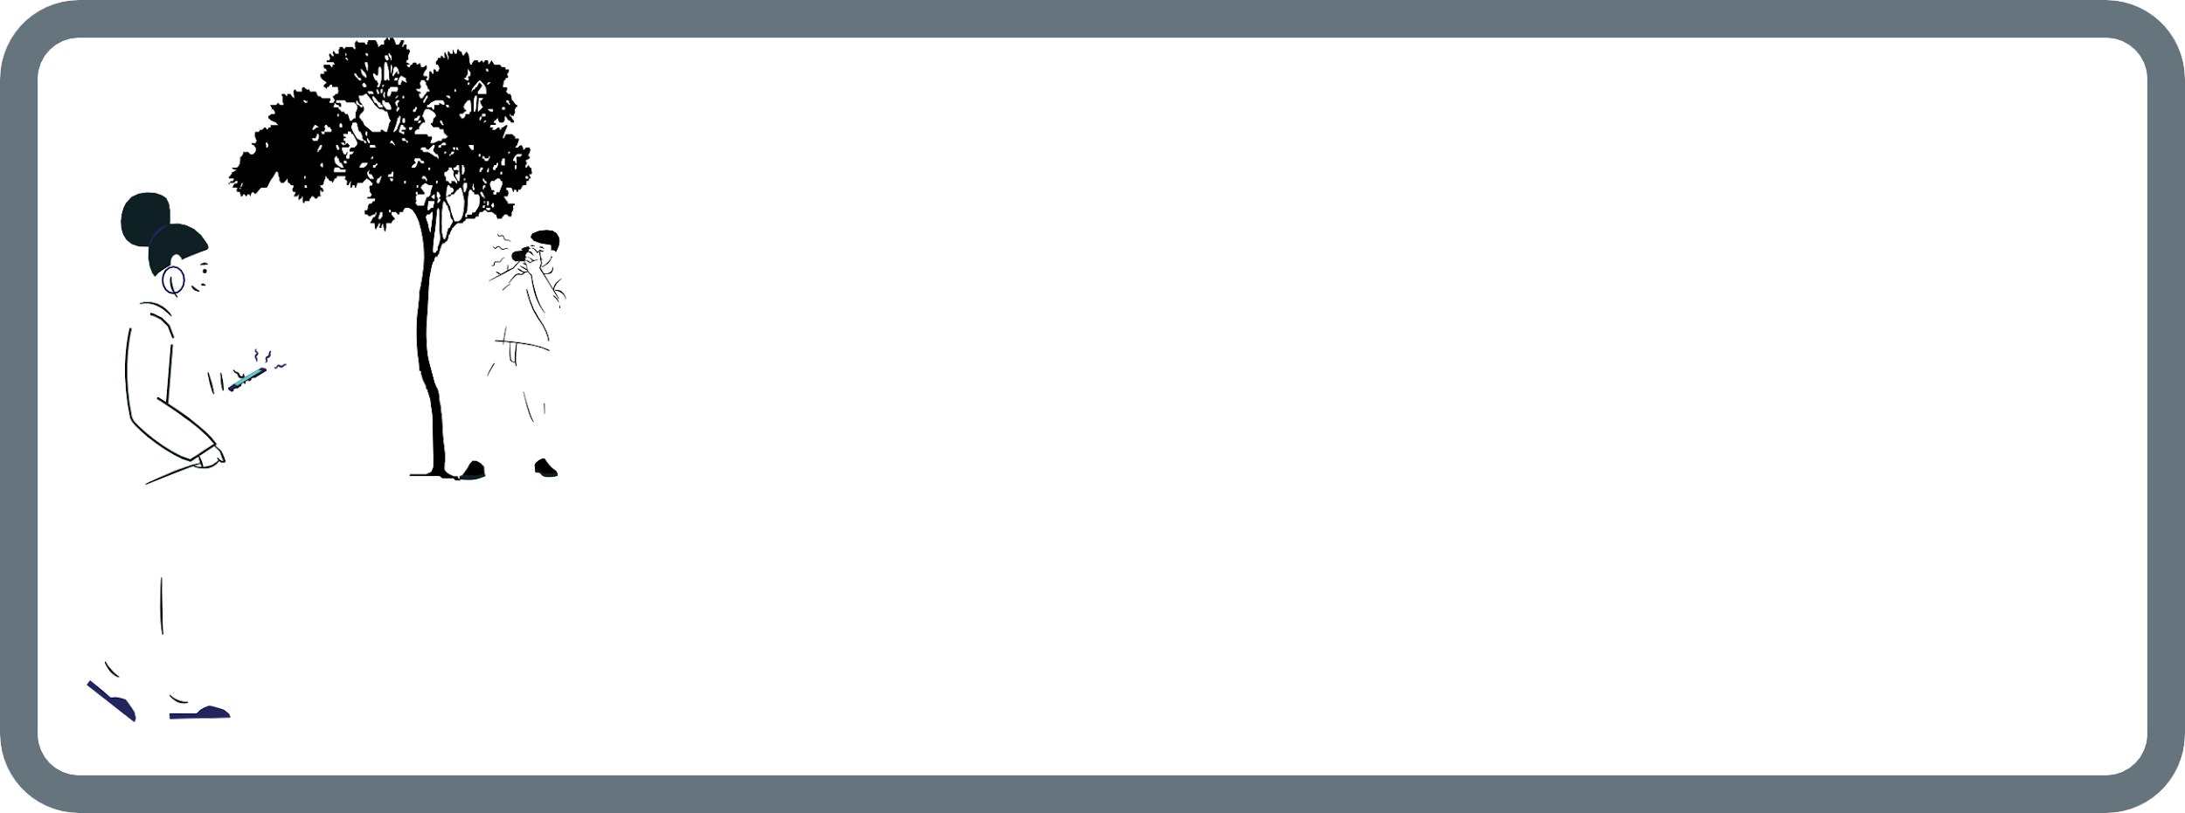

HIDDEN PHOTOS

You browse the Instagram account of famous local photographers and find a photo of you there. You think the photos were taken while you were walking in the park. The photos are intimate. There is information on Instagram that the series of photos is part of the "Hidden places, hidden photos" project. The photos are personal, and you can see your face there. You know that you have never participated in any project and you have not allowed anyone to publish the photos of you. It's not only about photos, but about the fact that you were followed by somebody in order to take them.



STOLEN PHOTO
You are a novice photographer. Your main places of sharing the photos are social media portals. You publish all your works under your name. Your friend sends you a link to a travel blog, where he found the photo of a young woman taken by you a month ago. In the bottom of the photo, you can see your name. However, you know that the model gave you permission to publish this photo only on your websites and accounts.

USING DATA IN A WRONG WAY
You are a user of a buy and sell portal. You announced the sale of the living room furniture. In order for the interested buyers to be able to contact you, you provide your name, surname, telephone number and e-mail address. After a few days, you receive a lot of phone calls and e-mails from companies offering you various marketing services. You do not get any answers from them when you ask where they found your data.





AN ACCESS TO YOUR CONTACT LIST
You have installed the latest mobile application for online shopping. It is a popular tool, lots of users praise its features and clarity. You exchanged text messages with your friends, as you were looking for the best insurance for your car. When you finished, you immediately opened a browser to check the option that your friend had recommended you before. Immediately after that you notice that you see all insurance companies ads, but you know that you have never looked for an insurance before on your phone. You think that your privacy has been violated because of a new application.

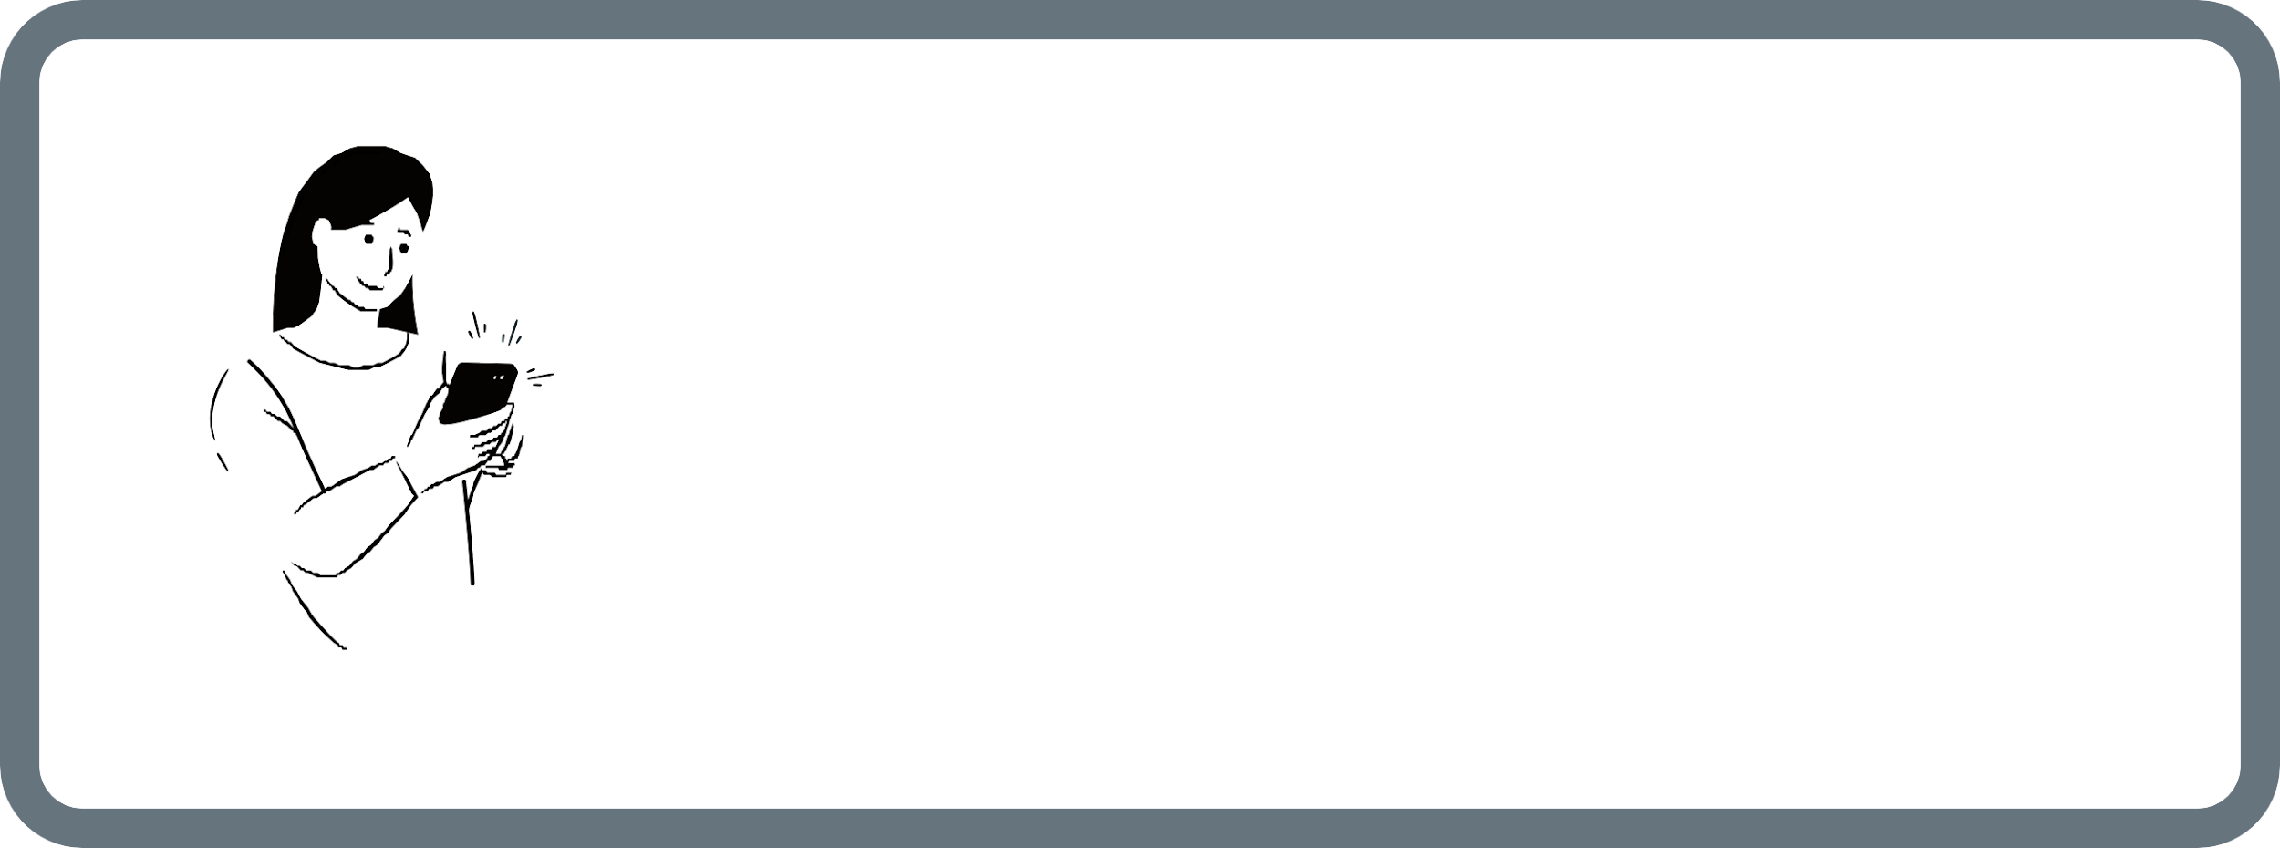

RESPONSIBILITY OF THE
PERSONAL DATA CONTROLLER

You applied for the project called "Better world for young people" in 2018. You participated in lots of workshops and professional internships. The project ended 5 months ago. Even so, you still receive e-mails and phone calls from organizations regarding proposals to participate in new projects and activities.

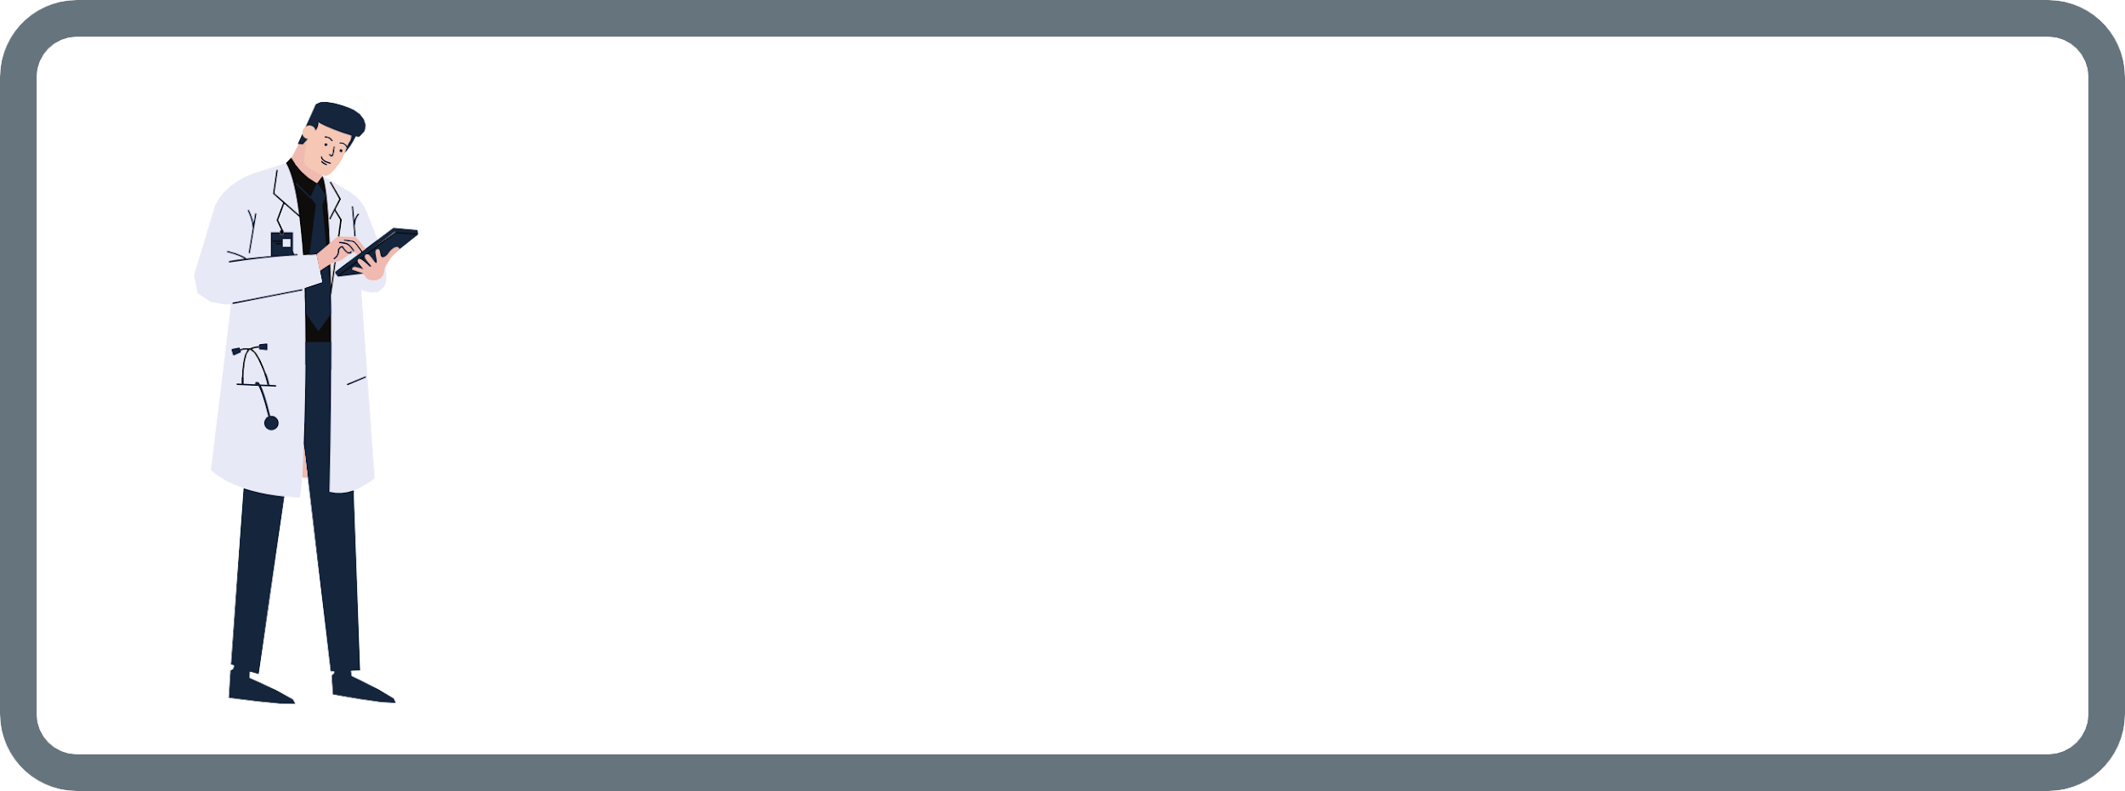

SENSITIVE DATA
You have done a periodic medical examinations at the request of your employer. The doctor told you that the test results turned out to be positive. Without reading the information, you took the envelope with the results from the hospital's reception and handed it over to your employer. An hour later, your employer informed you that the test results do not concern your, but someone else's details. There was probably a mistake at the laboratory reception and therefore sensitive data got into the hands of third parties.

LENDING A DEBIT CARD

You lost your debit card. You agreed with your sister that you will use her card until they send you a new one. You agreed to return the money by bank transfer later. Doing the shopping, the contactless payment does not work, so the seller asks you to give him the card to insert it into the electronic payment terminal. The seller notes that the card belongs to a woman,and you are a man. The name "Anna" and her signature are there. The seller informs you that he will not accept the payment because the card does not belong to you, despite your explanation that the card belongs to your sister and you know the pin and have her consent to use the card.

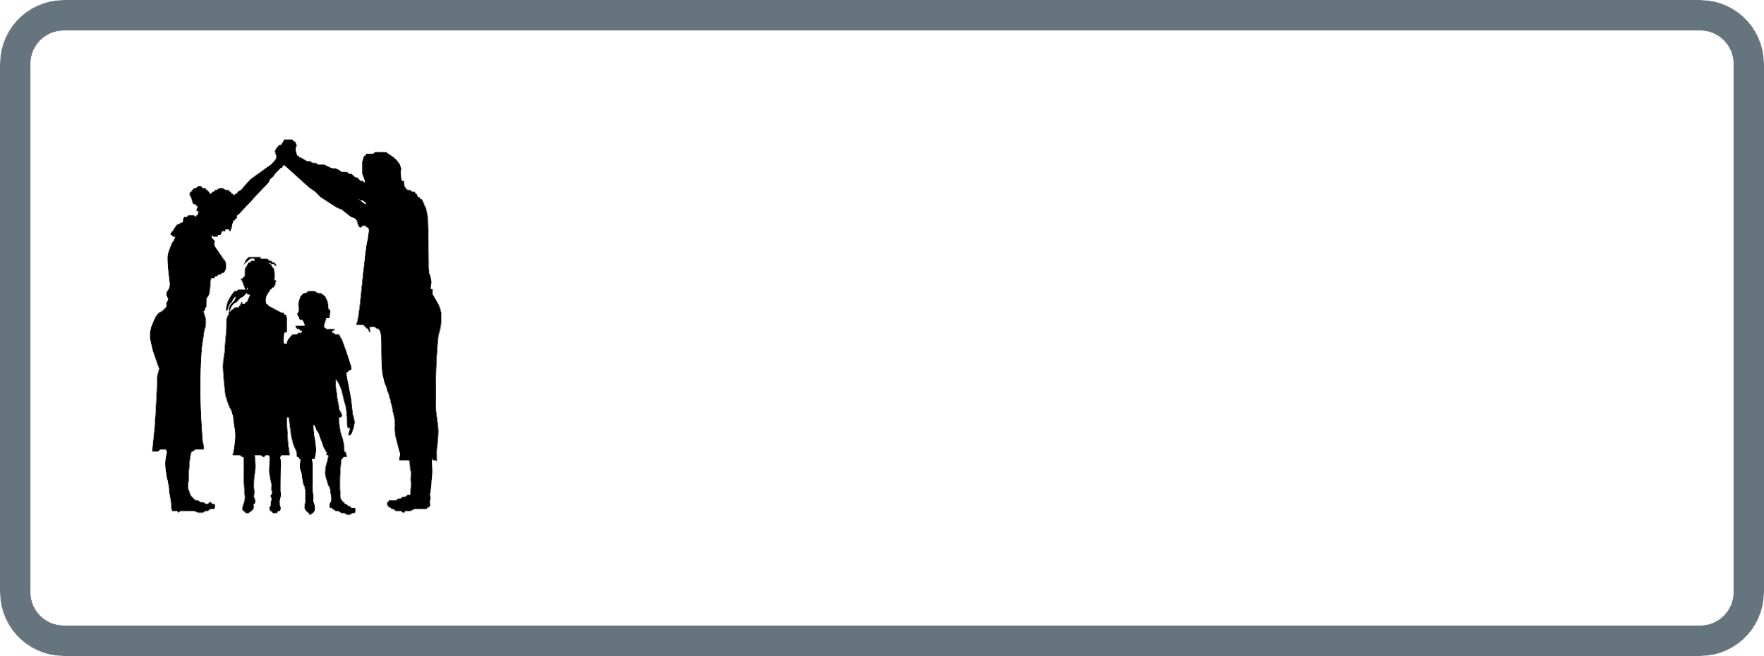

PARENTAL CONSENT
You've noticed that photos of your children are constantly appearing on your school's social media website. The photos were taken at school events and projects by some external institutions
that you have no idea about.

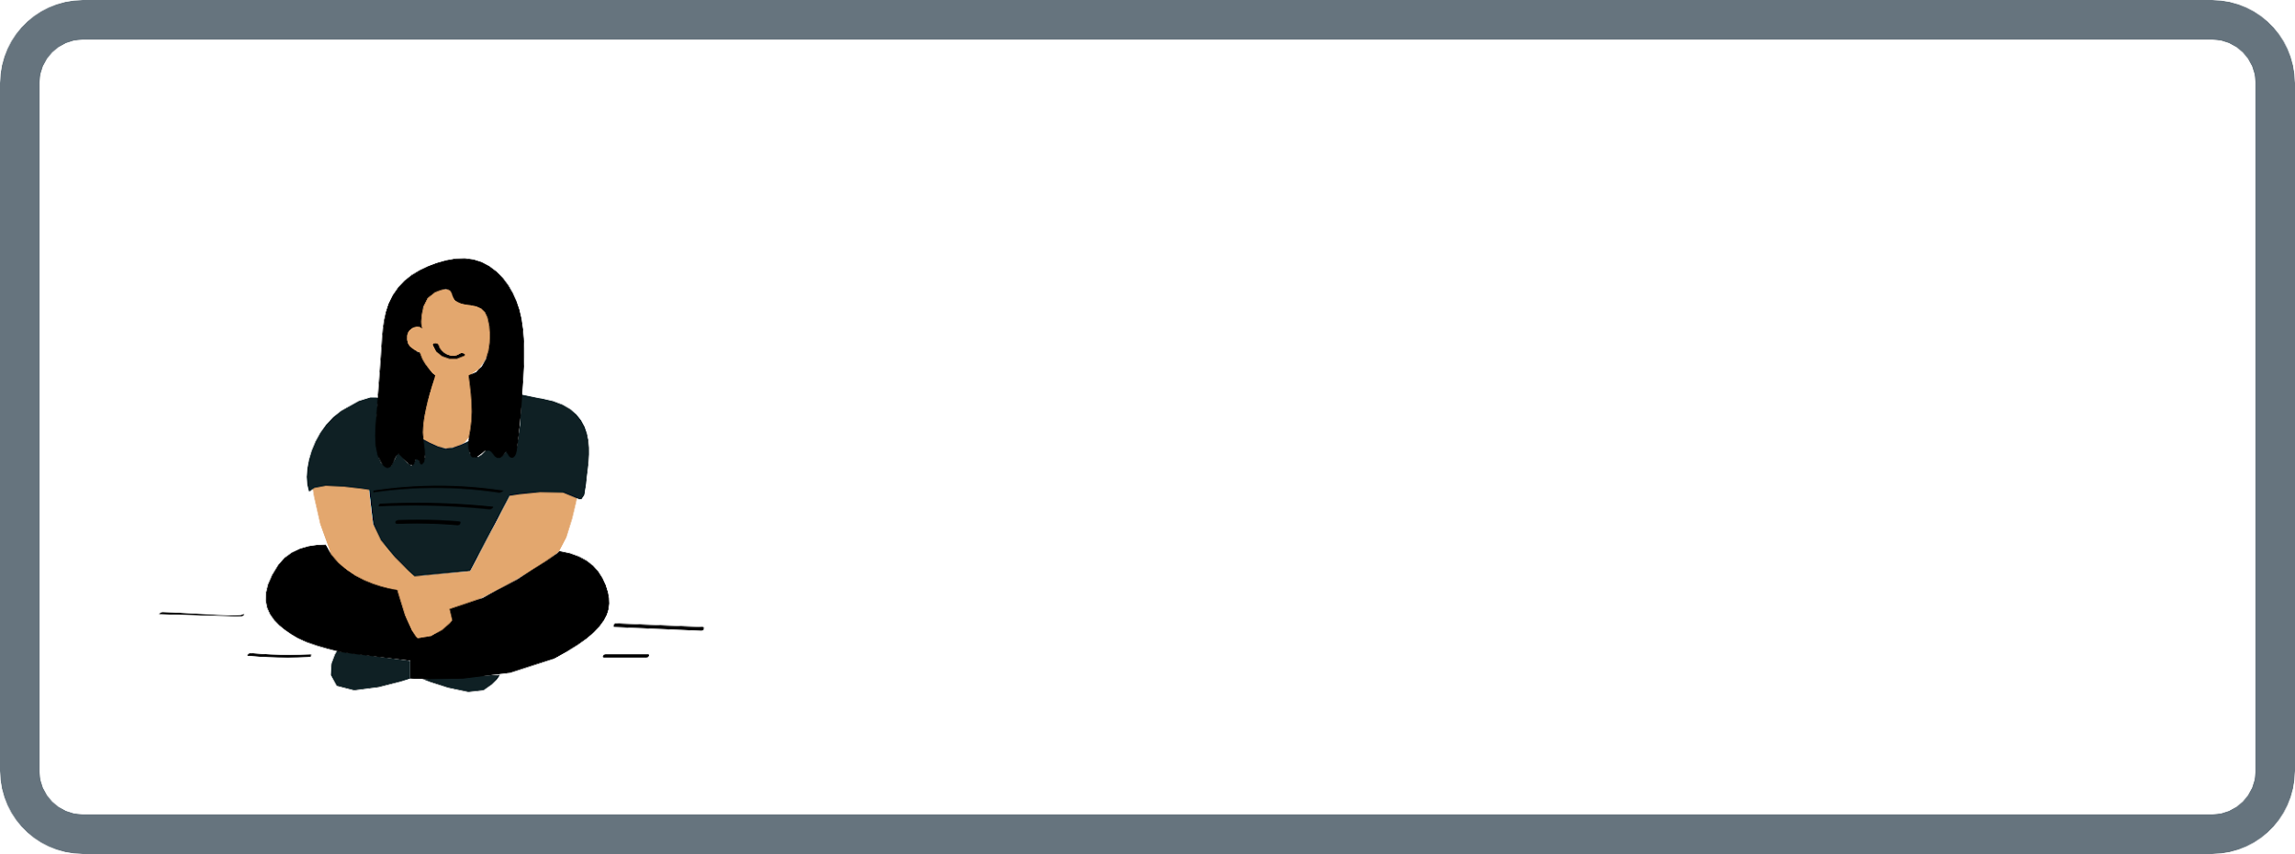
HUMAN CRUELTY

You've noticed that your social media profile picture was laughed at by a group of people that made fun of the overweight. It is a group made up of teenagers who harass people they believe are obese. You've noticed that there are your original photos there, as well as those edited with a graphic equalizer that present you in an even more mocking way.

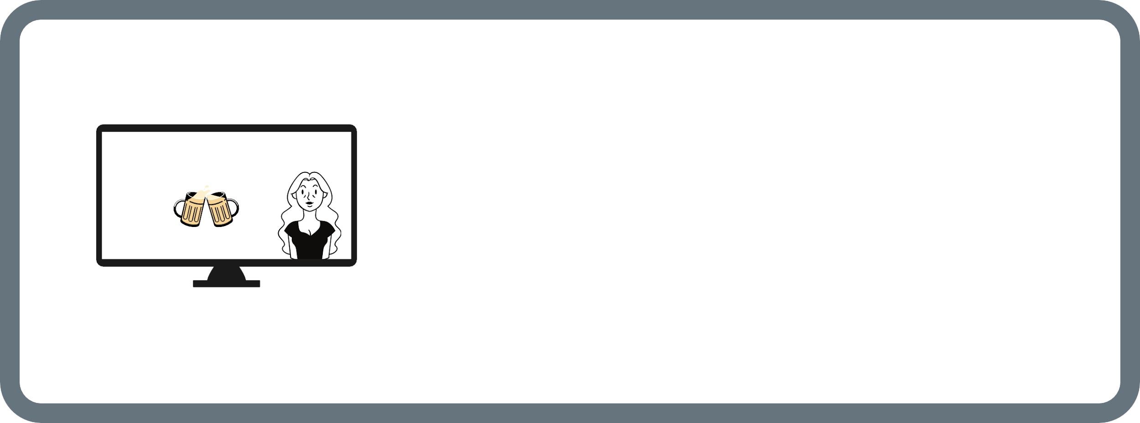


ADVERTISING AND MY IMAGE
You are auditioning for an ad on alcoholism prevention amongst the young people. The scenario assumes your speech and showing you in a group of people sitting in the park. You have a signed contract with co-creators, you agreed to share your image, and you get paid for the participation. Advertising appears on the Internet. You feel that your image has been used inappropriately. In the ad you are presented as an alcohol addict, your speech was substituted (the voice does not belong to you). The content is offensive.

